High School
Yearly Examination
2014
Year 10

Mathematics Course
General Instructions  - Reading time: 5 minutes  - Working time: 2 hours  - There will be a short break between Section 1 and Section 2  - Write using black or blue pen  - You may use a pencil to draw or complete diagrams  - Attempt ALL questions  - Approved calculators may be used in Section 2.  - Write your Name and Teacher’s Name in the spaces provided.  - A formula Sheet is on the reverse of this page and can be detached and used in all sections of the test. | Total Marks – 100  Section 1  Non Calculator Section.  25 marks  Time allowed for this section is 30 minutes.  Write all answers in the spaces provided.  Section 2  Time allowed for this section is 1 hour and 30 minutes.  Part A  Multiple Choice Section.  Mark your answers on the separate answer sheet at the end of the examination.  50 marks  Part B  Longer Answer Section.  Write all answers in the spaces provided.  25 marks

Formula Sheet
Pythagoras’ Theorem
c = hypotenuse
a and b are the shorter sides

Circumference of a circle
d = diameter

Area of a circle
r = radius

Area of a parallelogram
b = base
h = perpendicular height

Area of a rhombus or kite
x and y are the diagonals

Area of a trapezium
h = perpendicular height
a and b are the parallel sides

Volume of a prism
A = area of base
h = perpendicular height

Volume of a pyramid
A = area of base
h = perpendicular height

Volume of a cylinder
r = radius
h = perpendicular height

Volume of a cone

Volume of a sphere
Surface Area of a Cylinder

Surface Area of Cone
r = radius
l = slant height

Surface Area of a sphere

Trigonometric formulae for a triangle ABC.

Sine Rule

Cosine Rule
or
Area of a triangle
Simple interest
P = Principal
R = interest rate per time period as a decimal
T = number of time periods

Compound Interest
A = Final amount to which the investment grows
P = Principal
r = interest rate per compounding period as a decimal
n = number of compounding periods
Depreciation
SV = Salvage Value to which the initial value falls
IV = Initial Value
r = depreciation rate per compounding period as a decimal
n = number of compounding periods

Gradient of a line
and are points on the line
m = gradient

Midpoint of a line segment

Length of a line segment
Equation of a line
or
b = y intercept

Yearly Examination
Mathematics

Class/Teacher ______________________

Name______________________

Section 1

25 marks
Time allowed for this section is 30 minutes

Answer Questions 1–25 in the spaces provided.

Calculators are NOT to be used in this section.

There will be a short break between Section 1 and Section 2.

Section 1 Non Calculator Section
 | Write all working and answers in the spaces provided on this test paper.
1. | 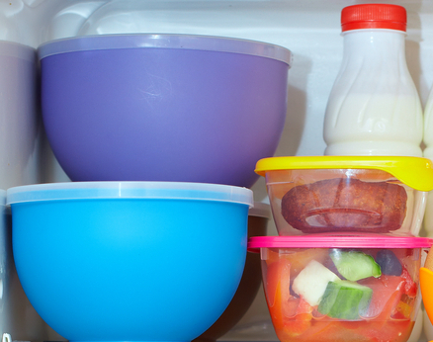  Mitchell takes five containers from the fridge.  The temperatures of the containers are shown below.  3º C, -2º C, -6º C, 0º C and -15º C  Write the temperatures in increasing order.  ……….…………………………………………………  ………………………………………………………….
2. | 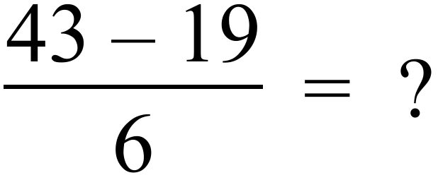  …………………………………………………………………………………………………………….  …………………………………………………………………………………………………………….
3. | 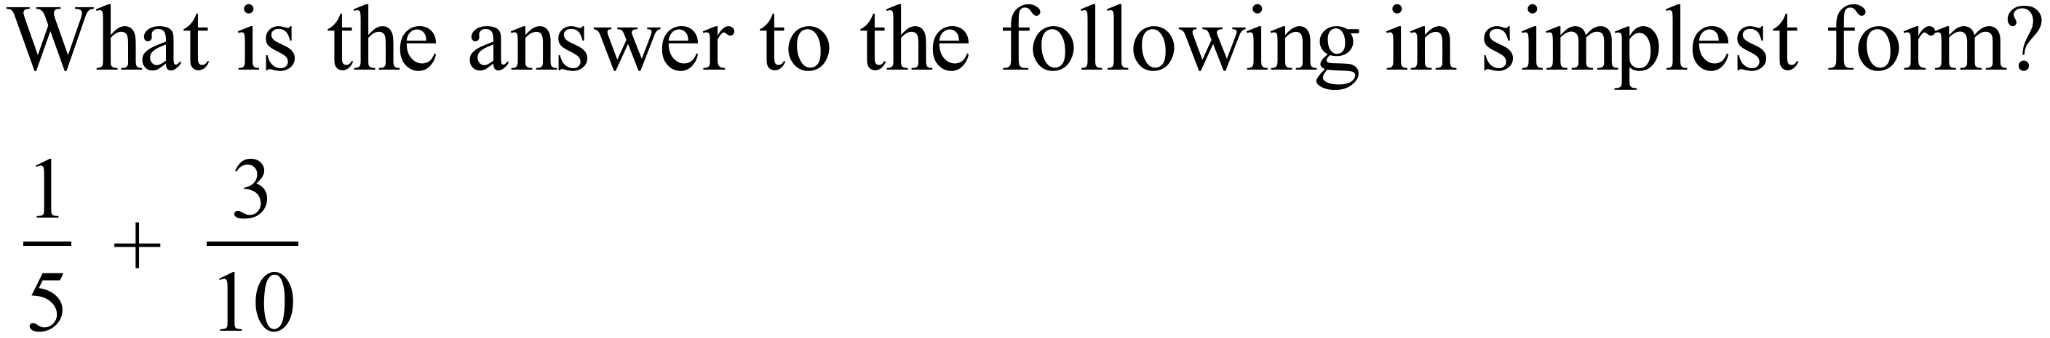  …………………………………………………………………………………………………………….  …………………………………………………………………………………………………………….
4. | 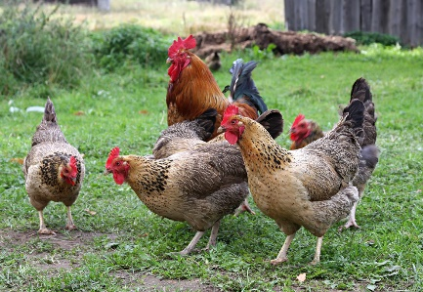  Emilia finds that only 14 of her 40 hens are laying eggs.  What percentage of her hens are laying eggs?  ……………………………………………………………  ……………………………………………………………
5. | There are 30,000 males living in the town of Ammaville.  The ratio of males to females living in the town is 15 : 16.  How many females live in Ammaville?  …………………………………………………………………………………………………………….  …………………………………………………………………………………………………………….
6. | 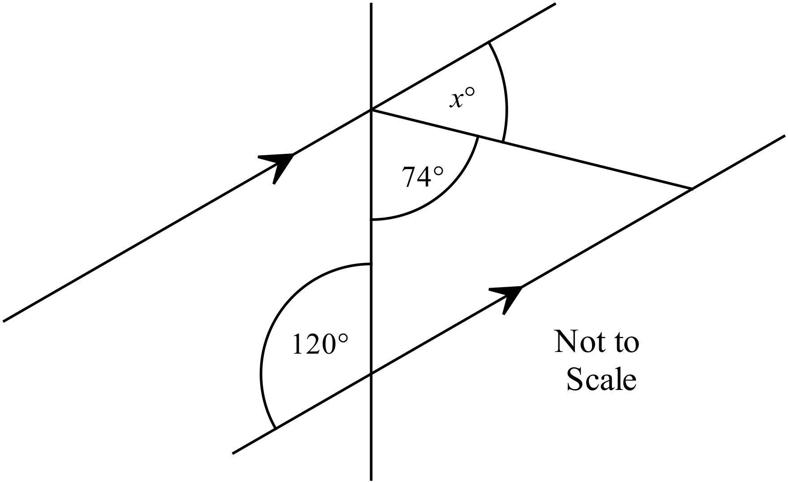Find the value of x in the diagram.  ……………………………………………………  .………………………………………………….  ……………………………………………………  …………………………………………………….
7. | A logo is to be created taking the design shown and adding an extra section which is a rotation through 180º of the design shown about the point C.  Complete the design of the logo. (Use geometric instruments.)  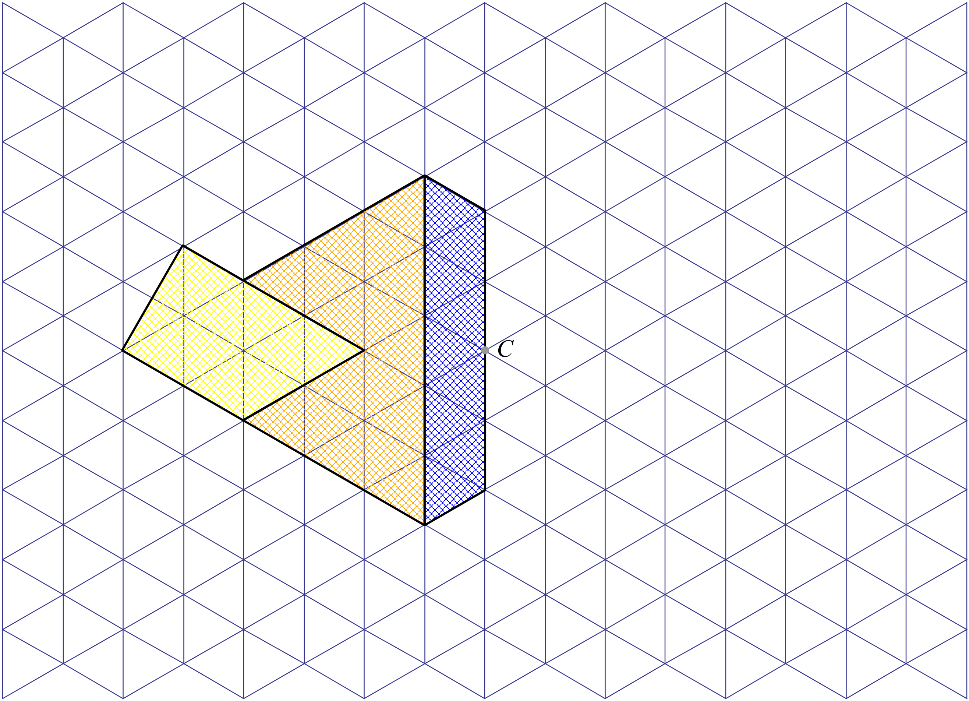
8. | Using the side AB shown, draw an accurate diagram of a rhombus ABCD with an internal angle of 60º at A. (Use geometric instruments including a protractor.)  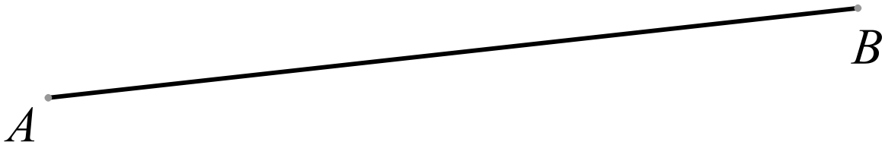
9. | 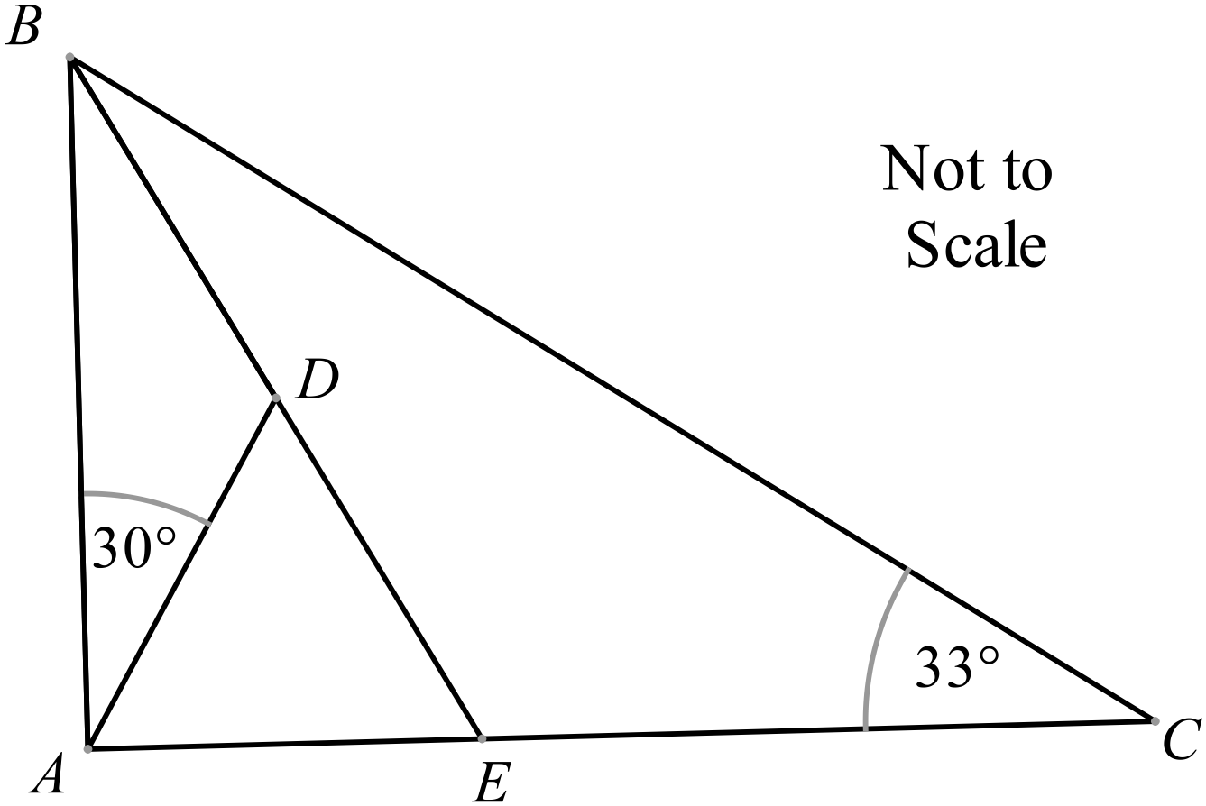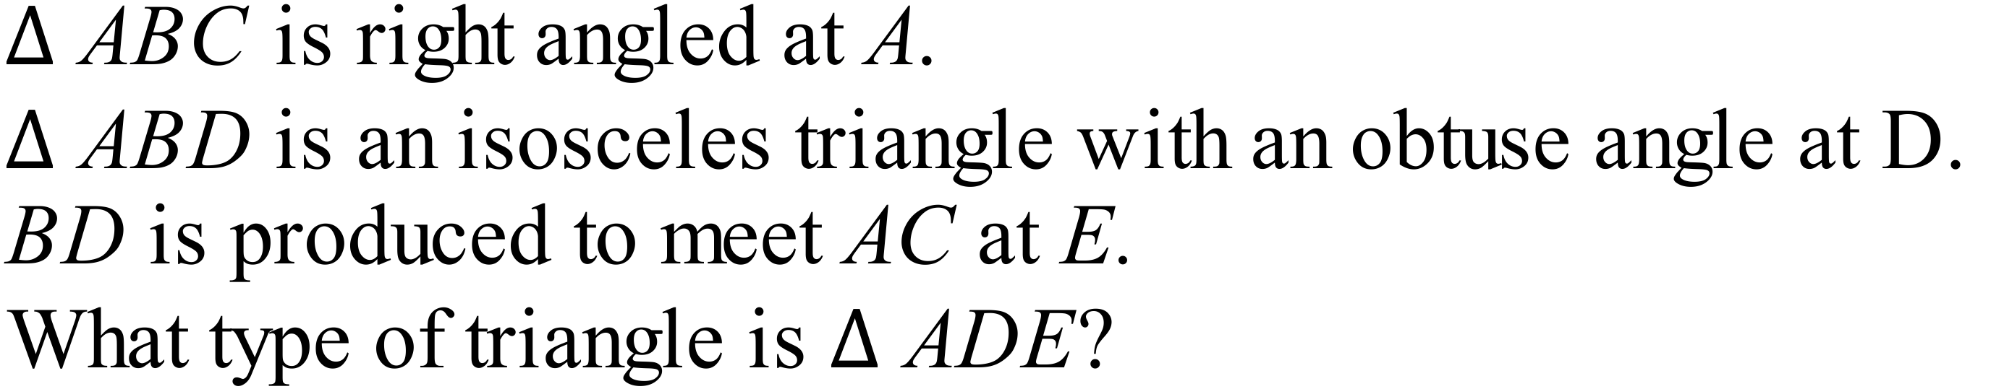  ……………………………………………………  .………………………………………………….  ……………………………………………………
10. | Olivia drives from Leeming in WA to Ballina in NSW, a distance of 4 333 km.  Write this as a distance in metres, using scientific notation.  …………………………………………………………………………………………………………….  …………………………………………………………………………………………………………….
11. | By measurement and calculation, find the perimeter of the polygon below, correct to the nearest millimetre.  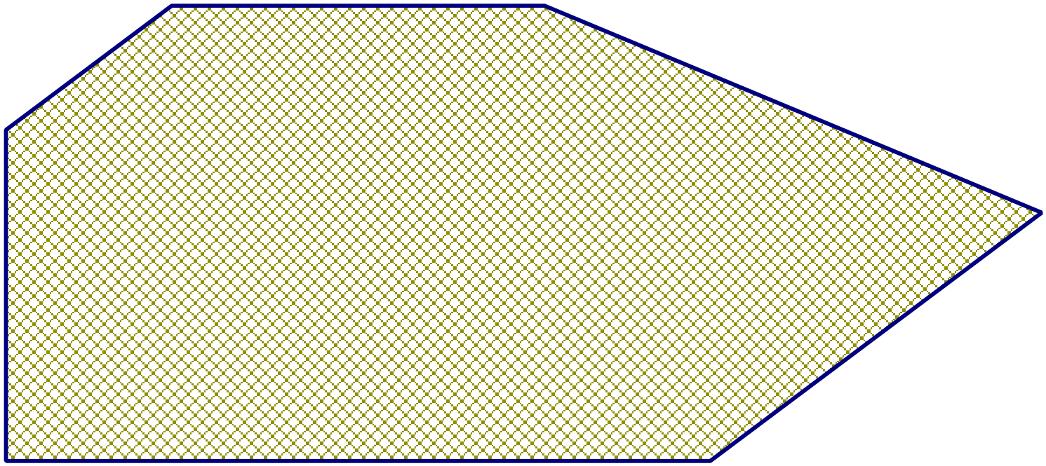  …………………………………………………………………………………………………………….  …………………………………………………………………………………………………………….
12. | Calculate the area of the shaded triangle shown below.  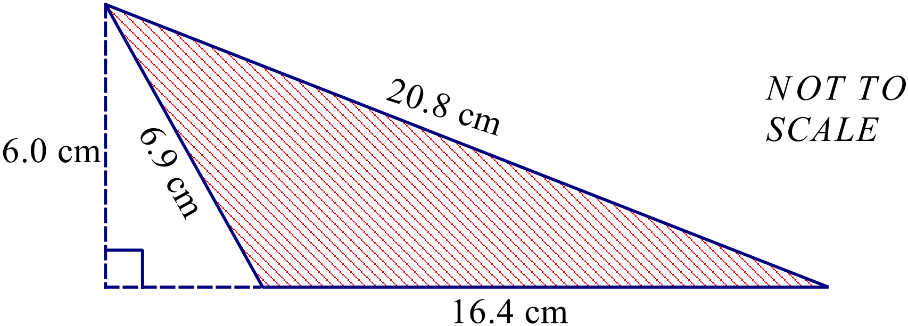  …………………………………………………………………………………………………………….  …………………………………………………………………………………………………………….
13. | 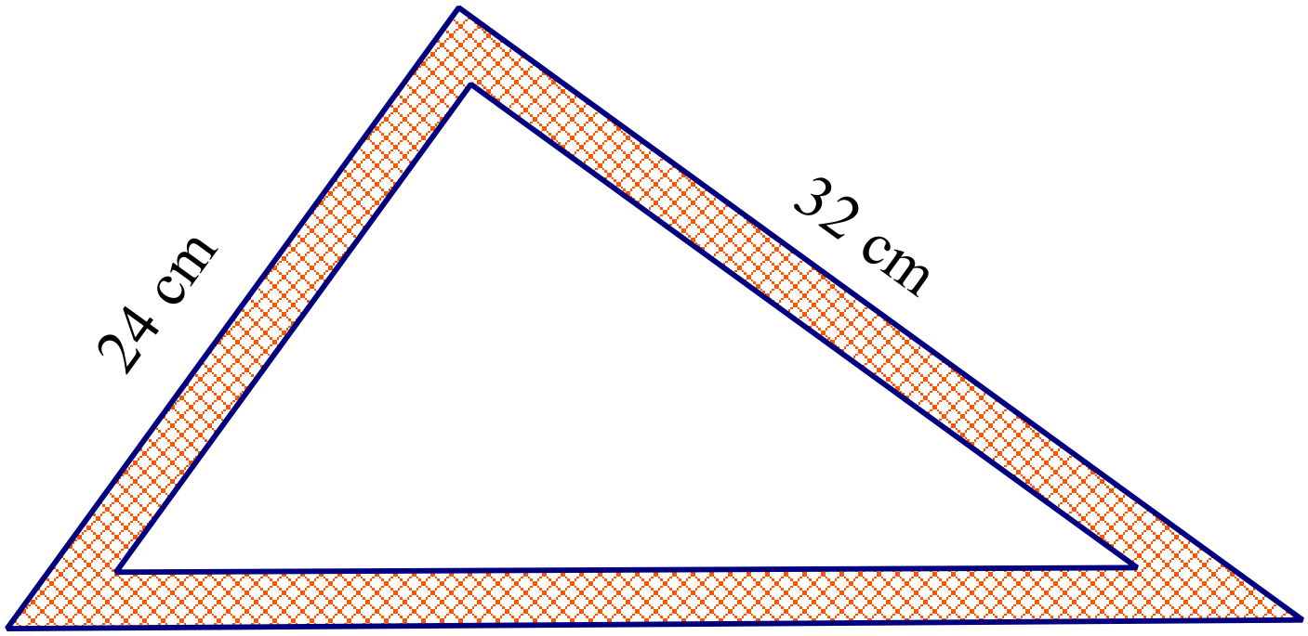A triangular set square has the measurements shown.  What is the length of it longest side?  …………………………………………………………………………………………………………….  …………………………………………………………………………………………………………….  …………………………………………………………………………………………………………….
14. | 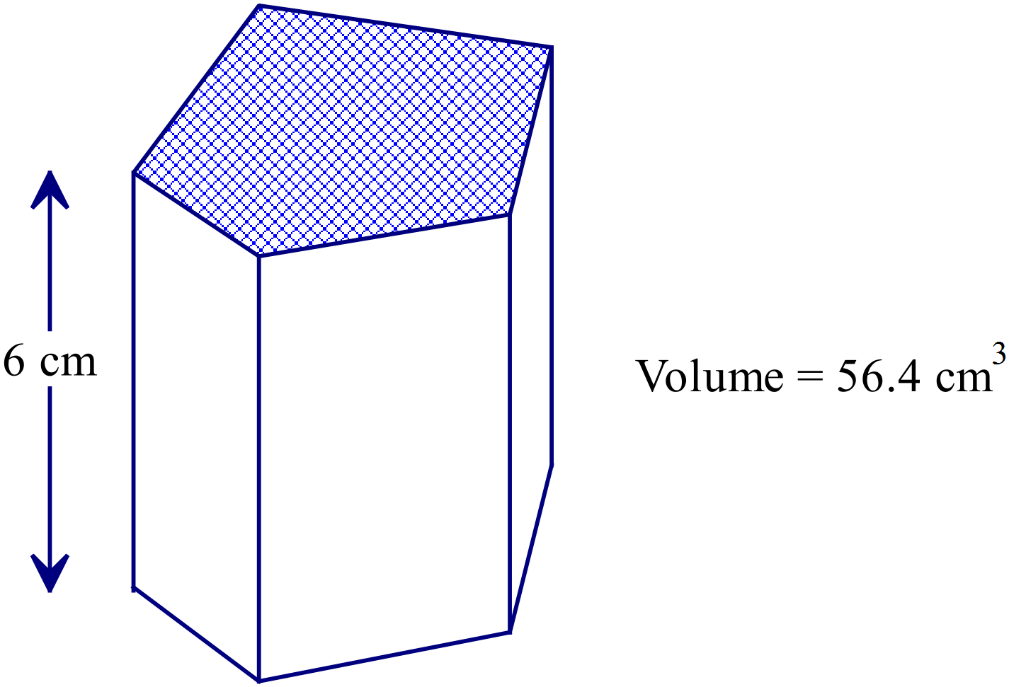What is the shaded area of the base of this prism?  ………………………………………………  ……………………………………………….  ..………………………………………………  ……………………………………………….
15. | Simplify 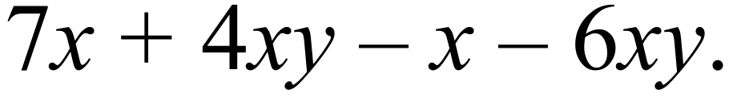  …………………………………………………………………………………………………………….  …………………………………………………………………………………………………………….
16. | Expand and simplify 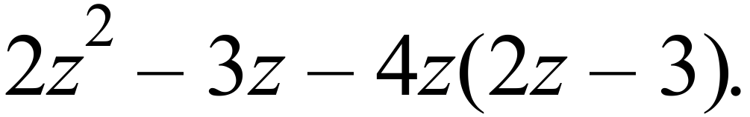  …………………………………………………………………………………………………………….  …………………………………………………………………………………………………………….
17. | Express as a single fraction in simplest form: 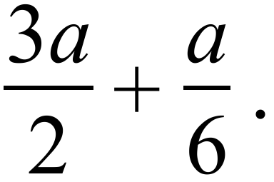  …………………………………………………………………………………………………………….  …………………………………………………………………………………………………………….
18. | 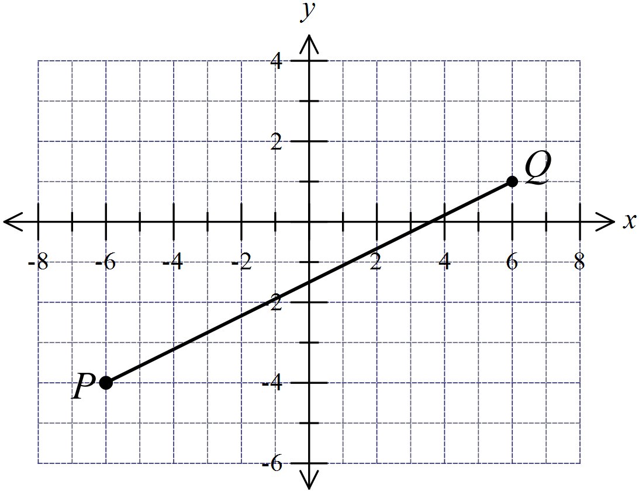P and Q are the points (-6, -4) and (6, 1) respectively.  Find the length of the interval PQ.  .…………………………………………………  ………………………………………………….  .…………………………………………………  ………………………………………………….
19. | Find the value of w for which:  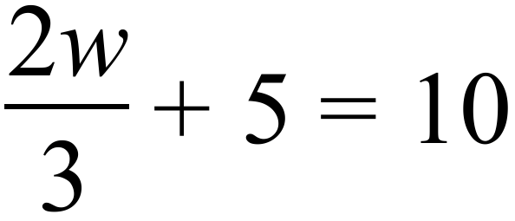  …………………………………………………………………………………………………………….  …………………………………………………………………………………………………………….  …………………………………………………………………………………………………………….
20. | Beau chooses a square at random from those shown on the grid below.  What is the probability that he chooses a number that ends in a 2 or a 4?  …………………………………………………………………………………………………………….  …………………………………………………………………………………………………………….
  42 | 15 | 27 | 34 | 62
  72 | 48 | 18 | 33 | 55
  37 | 52 | 15 | 32 | 17
  57 | 44 | 38 | 19 | 22
21. | The weather bureau reports that the probability of rain at 3 pm tomorrow is 28%.  Based on this, what is the probability that it won’t rain at 3pm tomorrow?  …………………………………………………………………………………………………………….  …………………………………………………………………………………………………………….
22. | The stem and leaf plot shows the scores from 11 shots at a dartboard.  The total score from the 11 shots was 301.  What number is represented by X?  …………………………………………………………………………………………………………….  …………………………………………………………………………………………………………….
  0 | 2
  1 | 1 | 2
  2 | 2 | X
  3 | 0 | 2 | 3
  4 | 2 | 3
  5 | 0
23. | The graph below shows the results in an election for their Year 11 representative on the SRC.  There were 150 votes counted altogether.  How many votes did the winner of the election receive?  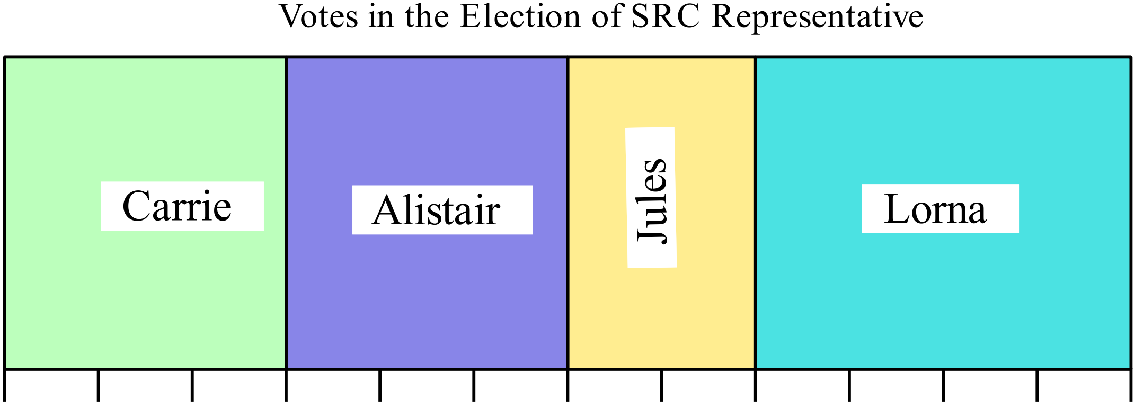  …………………………………………………………………………………………………………….  …………………………………………………………………………………………………………….
24. | Nathan’s average mark on his last four Science assessment tasks is 85%.  He has one Science task to go. What is the highest possible average he can achieve on the five tasks?  …………………………………………………………………………………………………………….  …………………………………………………………………………………………………………….
25. | Tess records her times for ten 100 metre sprints.  They were (in seconds) : 12.5, 11.2, 11.6, 11.9, 12.1, 11.4, 11.1, 11.4, 12.0, 11.0.  What is the interquartile range of the times?  …………………………………………………………………………………………………………….  …………………………………………………………………………………………………………….
 | End of Section I

Yearly Examination
Mathematics

Section 2

75 marks
Time allowed for this section is
1 hour and 30 minutes

This section has TWO parts

Part A – Fifty multiple-choice questions worth 1 mark each.
Mark your answers on the separate answer sheet provided at the end of the examination.
Part B – Longer answer questions worth a total of 25 marks.
Write all answers and working in the spaces provided on this examination paper.

Calculators may be used in this section.

Do not commence Section 2 until you are instructed to do so.

Use the multiple choice answer sheet at the end of the paper to record your answers.
Completely shade the bubble corresponding to the correct answer for each question.

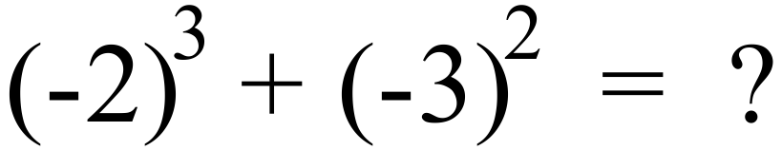

A. 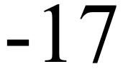 B. 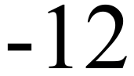 C. 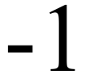 D. 
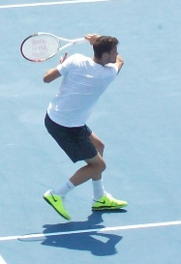
A tennis player hits a ball a distance of 24 m.
The ball takes half a second to travel the distance.
What was the speed of the ball?
A. 12 metres/second. B. 24 metres/second
C. 48 metres/second D. 96 metres/second
Shelley is paid to deliver catalogues.
She receives 84 cents for every 20 catalogues she delivers.
On one day, she went to a suburb where she delivered 2,500 catalogues.
What was she paid for that day?

A. $105 B. $210 C. $420 D. $595
Dayna invested $600 in an account which paid simple interest.
She was paid $180 in interest at the end of 2 years.
What was the annual rate of simple interest?

A. 3% p.a. B. 7.5% p.a. C. 15% p.a. D. 30% p.a.
AB and CD are intervals which intersect at G.
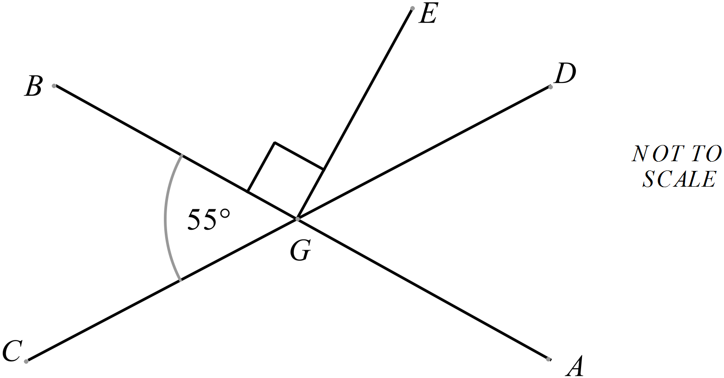EG is perpendicular to AB.



A. 35º
B. 45º
C. 55º
D. 125º
Which triangle below could be describes as follows?
A right scalene triangle.
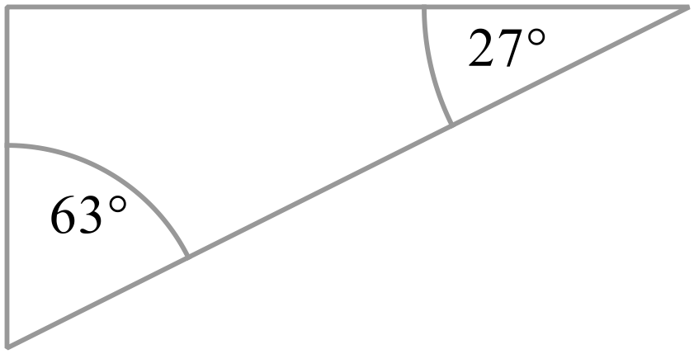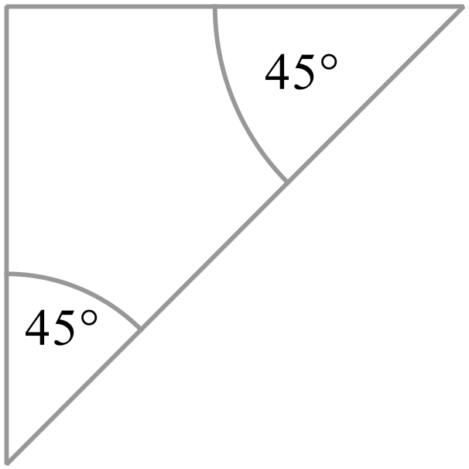 A. B.

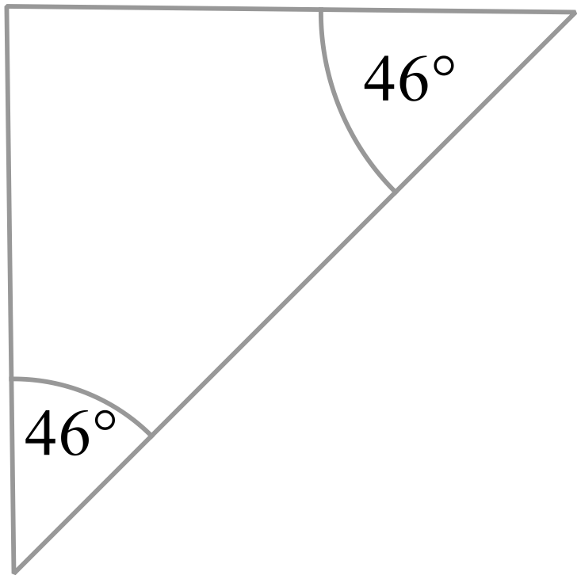
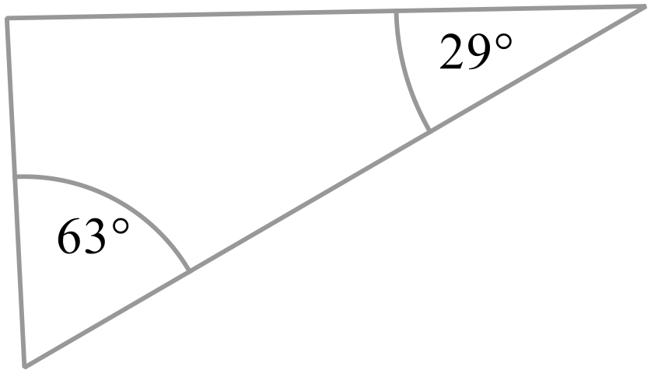 C. D.

PQRS is a parallelogram with diagonals which intersect at T.
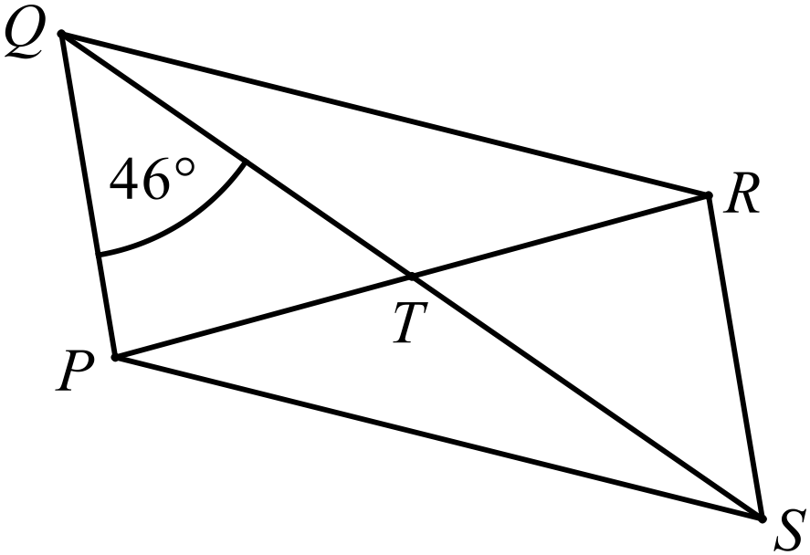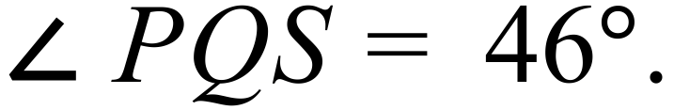
Which statement is true?
A. PR = QS
B. QT = TR
C. 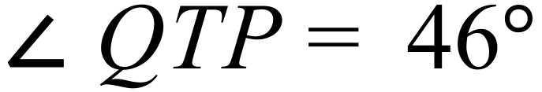
D. 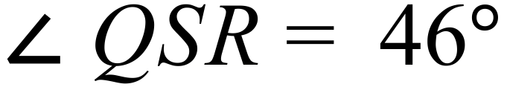
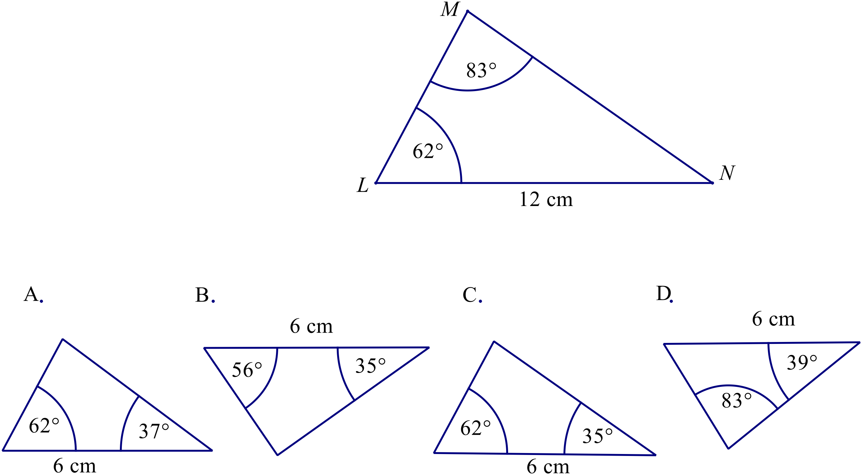Which triangle is similar to 

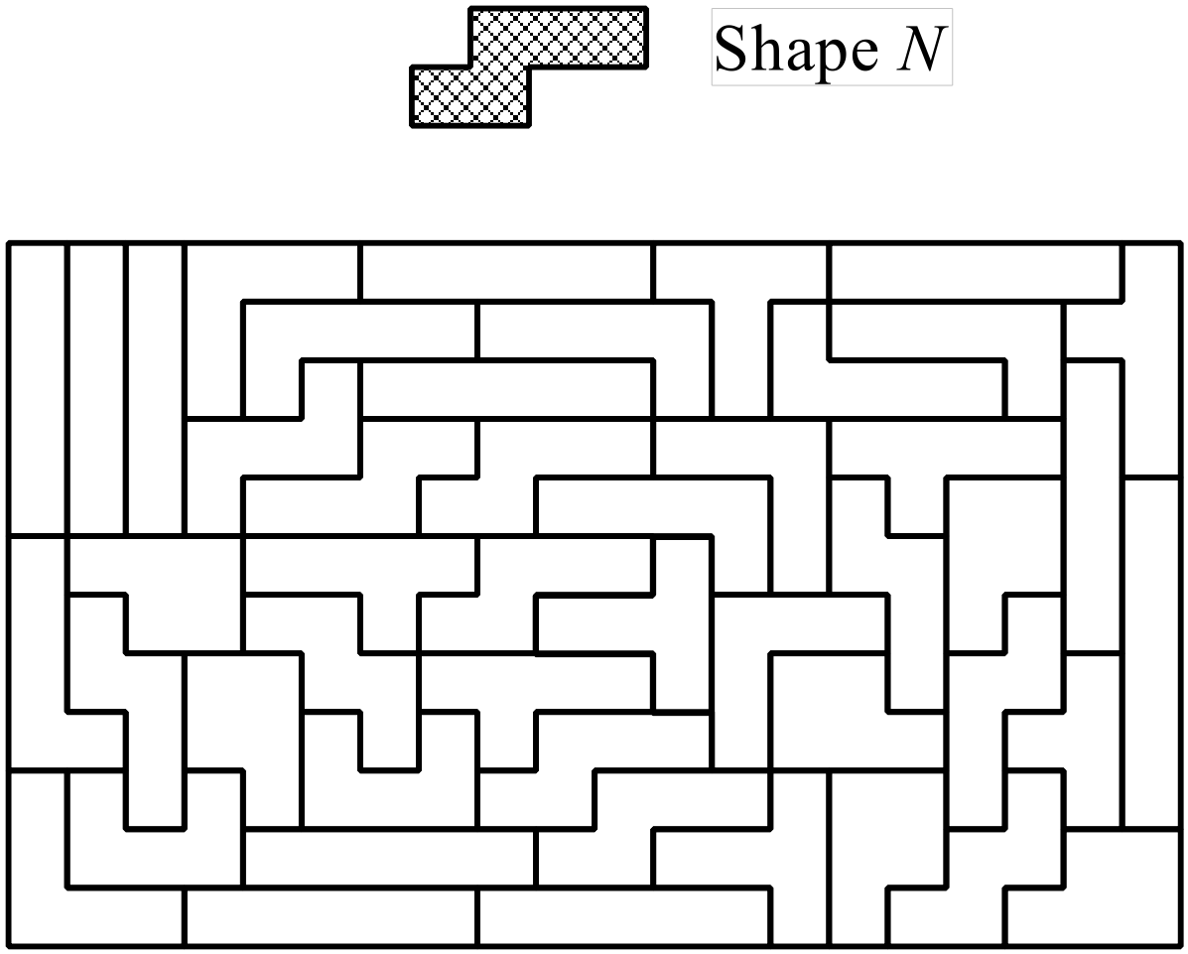The tiling design below is made up of shapes called pentominoes.
There are several different shaped pentominoes.
How many of the pentominoes in the design are congruent to Shape N.

A. 6
B. 7
C. 8
D. 9
The figure shown below is rotated through 270º in a clockwise direction.
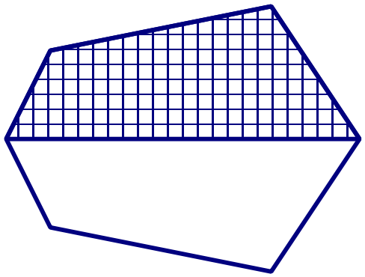

Which diagram shows the resulting image?
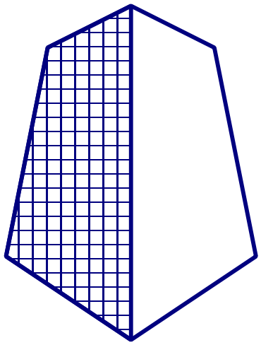
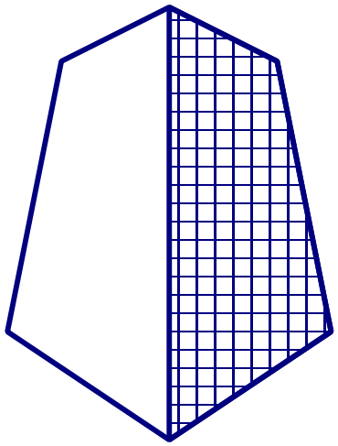 A. B.

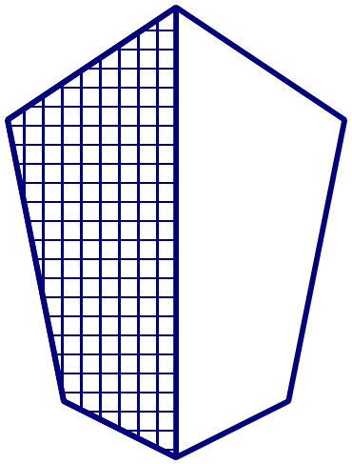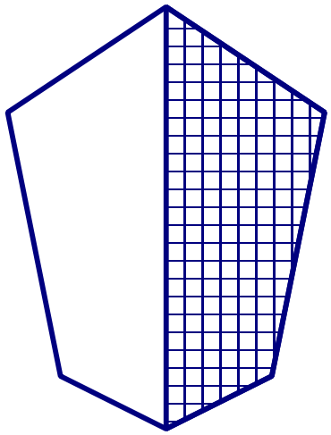 C. D.

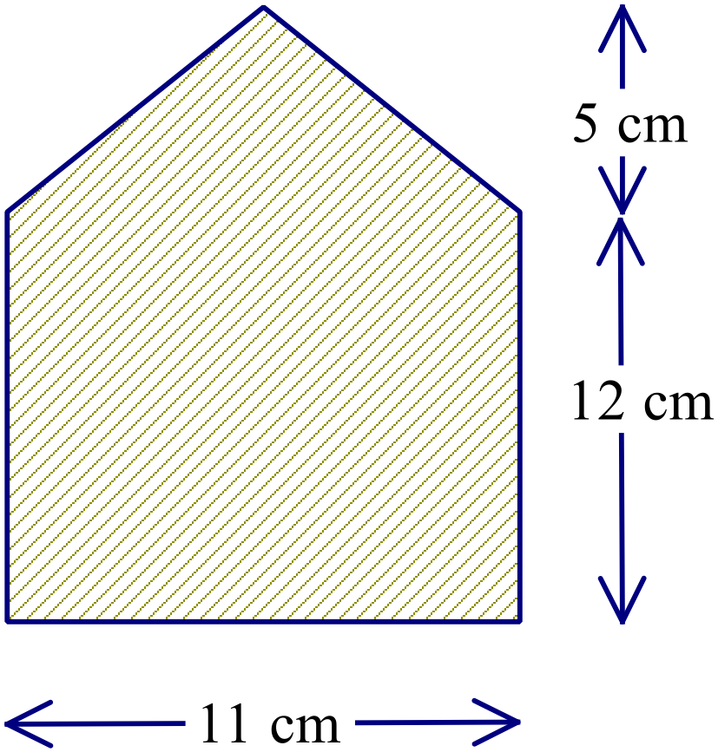Find the area of this shape.

A. 93.5 cm²
B. 132 cm²
C. 159.5 cm²
D. 187 cm²

Find the volume of this triangular prism.
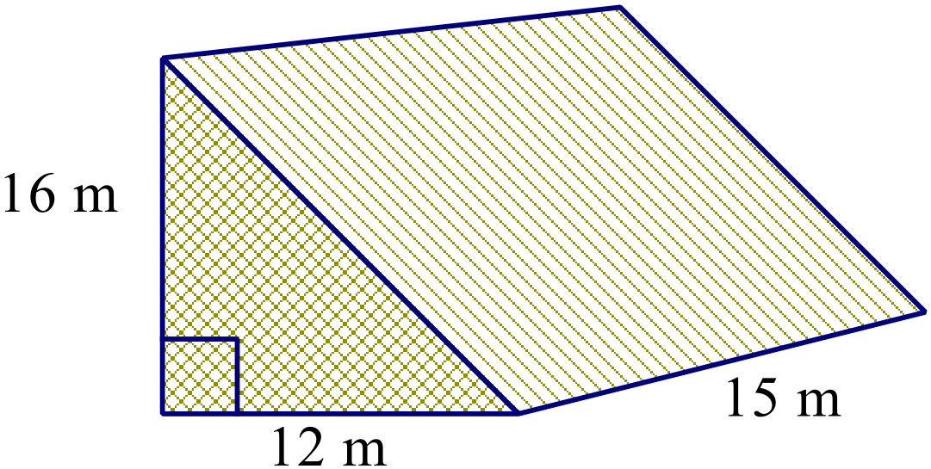
A. 115 m³
B. 1 440 m³
C. 2 160 m³
D. 2 880 m³
The size of a TV screen is advertised according to the length of its diagonal.
The TV screen shown is advertised as a 150 cm plasma TV.
Its screen has a horizontal width of 120 cm.
What is the vertical height of the screen?

A. 30 cm B. 90 cm C. 192 cm D. 270 cm
What is the value of 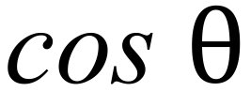 for the triangle below?
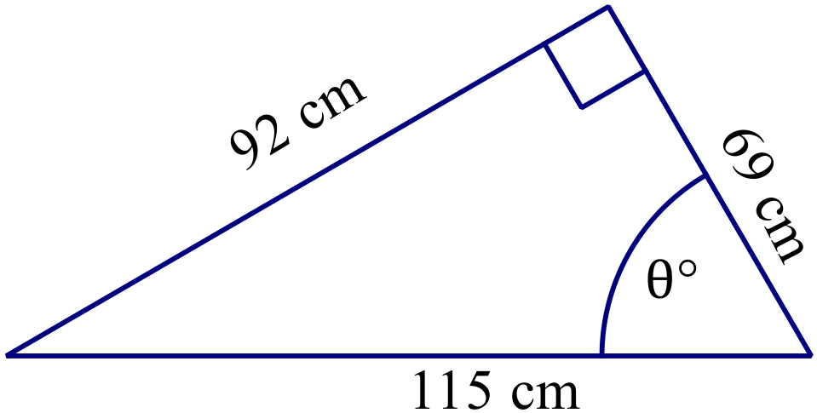
A. 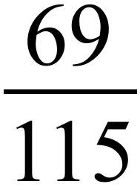
B. 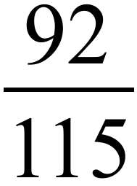
C. 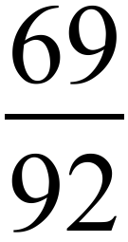
D. 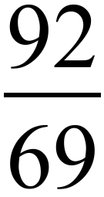
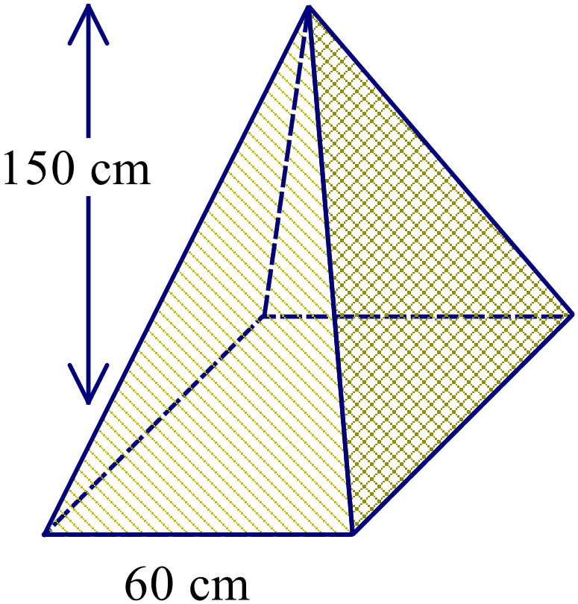Find the volume of this square pyramid.

A. 3 000 m³
B. 90 000 m³
C. 150 000 m³
D. 180 000 m³

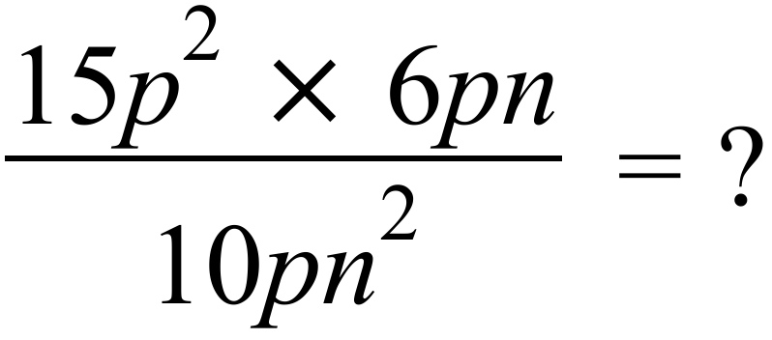
A. 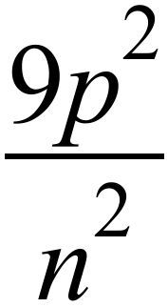 B. 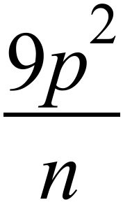 C. 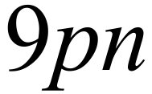 D. 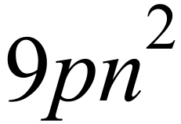
What are the coordinates of the midpoint of the interval joining the points U (-3, 8) and W (-7, -6)?
A. (-5, 1) B. (-5, 7) C. (2, 1) D. (2, 7)
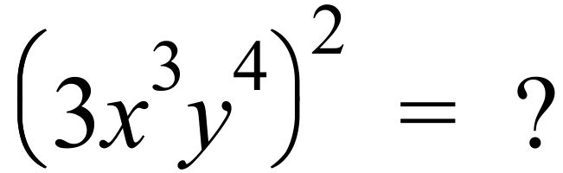
A. 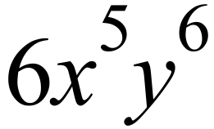 B. 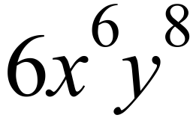 C. 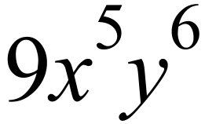 D. 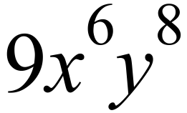
Use the formula 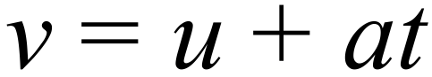 to find the value of a when v = 13.8, u = 1.8 and t = 2.5.

A. 1.2 B. 2.4 C. 3.6 D. 4.8
Which number plane graph could represent the equation 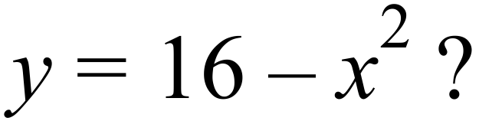
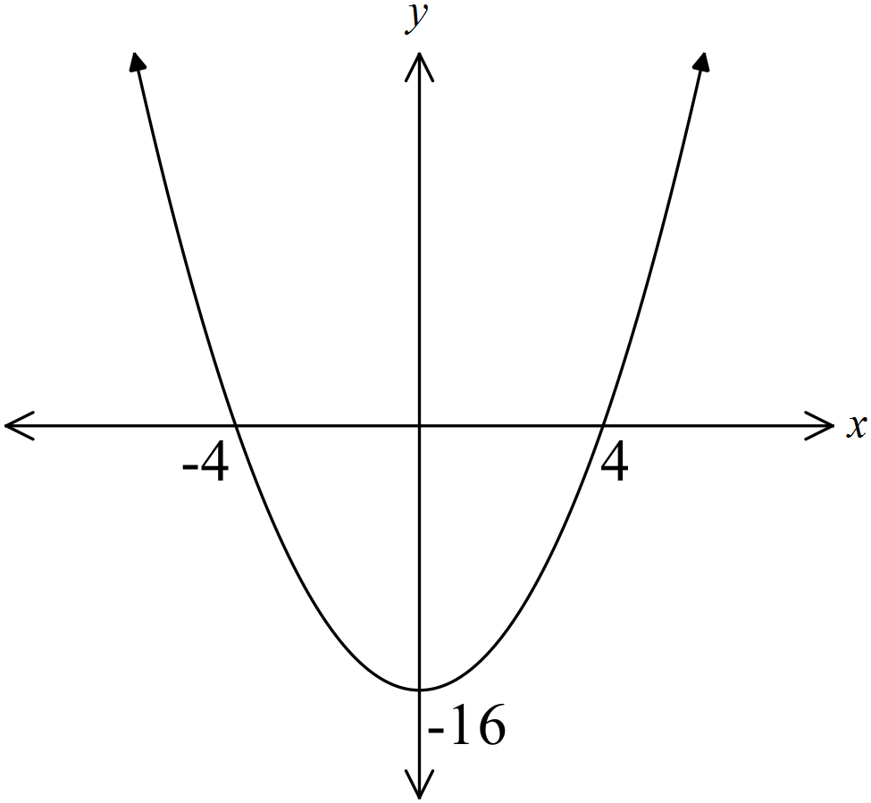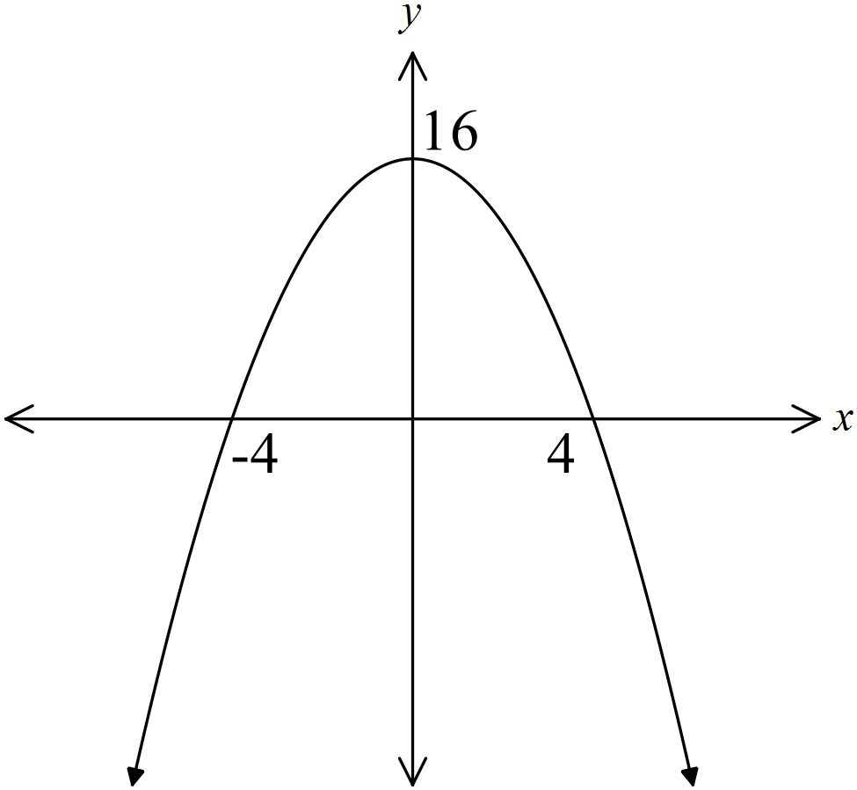A. B.

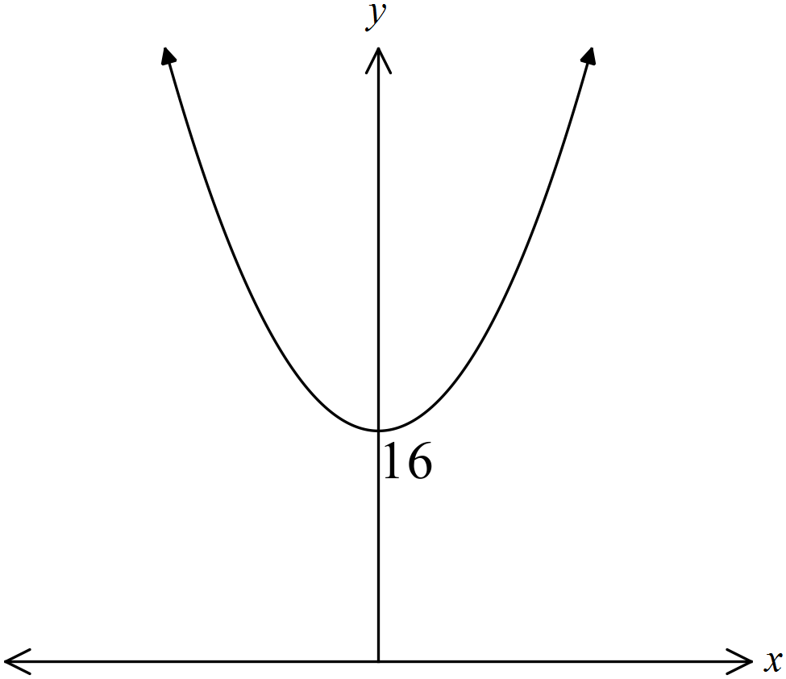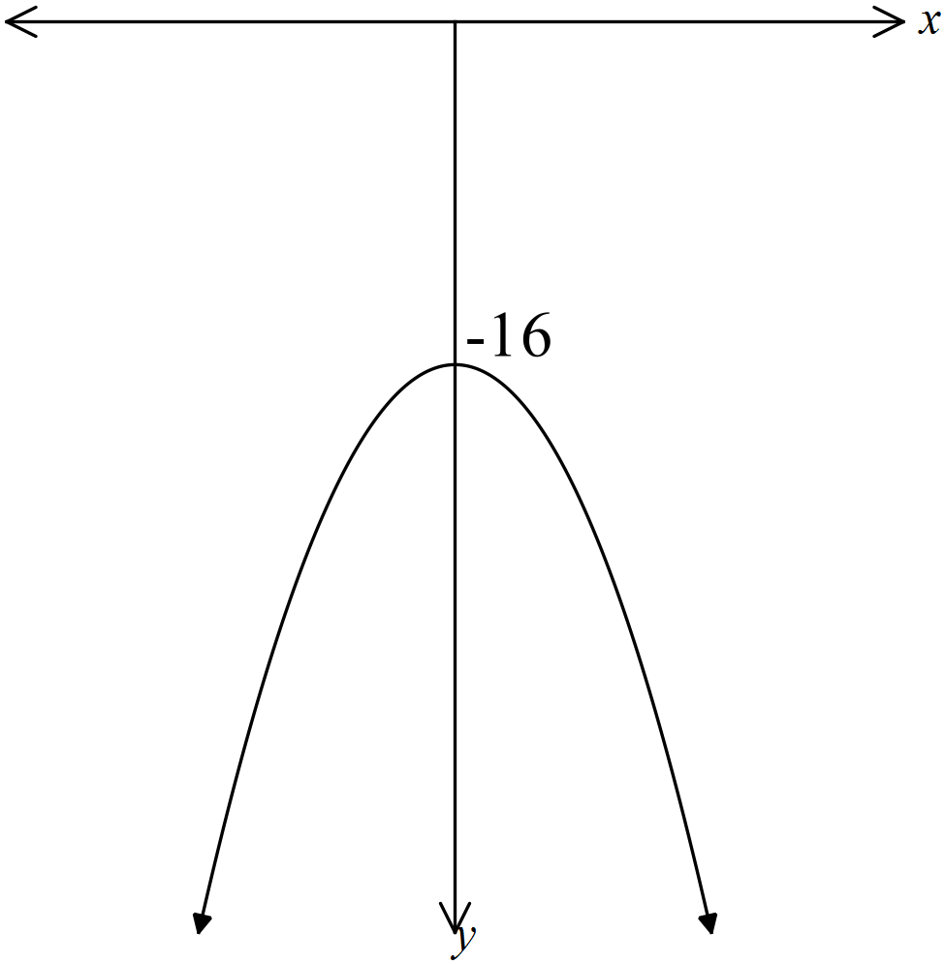 C. D.

An event is described as being very likely.
What decimal could describe its probability?

A. 0.2 B. 0.4 C. 0.6 D. 0.8
Last Tuesday, Matias did a survey of the customers at the convenience store where he works.
He asked 250 people out of the 2 000 people who came into the store to answer the question below.
What suburb do you live in?
Which is true?
A. Matias is using a census to collect categorical data.
B. Matias is using a sample to collect categorical data.
C. Matias is using a census to collect numerical data.
D. Matias is using a sample to collect numerical data.
Rick does a survey of the number of male and female employees in five companies.
The results are shown on the graph below.

Male

Female

Which is true?
A. 56% of Anderson’s employees are male.
B. 43% of Beattie’s’s employees are male.
C. Curran has half the number of female employees as Evans.
D. Dowler and Beattie have the same number of male employees.
The frequency histogram shows the family size in a survey of 20 families.
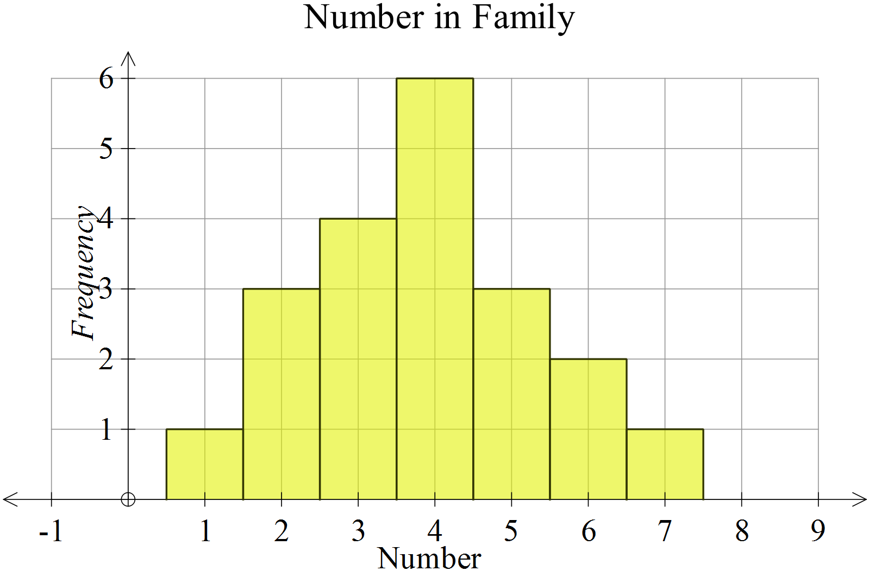

What was the mean family size (correct to 2 decimal places)?
A. 2.86 B. 3.85 C. 3.50 D. 4.00
The line graph shows the temperatures over a period of 24 hours at Hennessey.

Between what two times is the greatest change in temperature?
A. 8 am and 9 am
B. 12 pm and 1 pm
C. 7 pm and 8 pm
D. 9 pm and 10 pm
Shari is on an annual salary of $83 200, which is paid weekly.
Jerome is on an hourly wage of $43.80 for a 36 hour week.
Which is true?
A. Jerome earns $23.20 per week more than Shari.
B. Jerome earns $46.40 per week more than Shari.
C. Shari earns $23.20 per week more than Jerome.
D. Shari earns $46.40 per week more than Jerome.

Massimo buys a tablet computer by paying a deposit of $80 and monthly payments of $25 for 2 years.
The cash price of the tablet was $560.
How much did he pay in interest?

A. $40 B. $120 C. $160 D. $180
Nerissa invests $5 000 in an account that pays interest at 6.4% p.a. compounded annually.
She leaves the money in the account for three years.
How much interest does she earn?
A. $960.00 B. $1 022.75 C. $1 040.16 D. $6 022.75
Elliott buys a car for $40 000 and intends to keep it until its value has roughly halved.
The graph shows the value of the car as it depreciates.
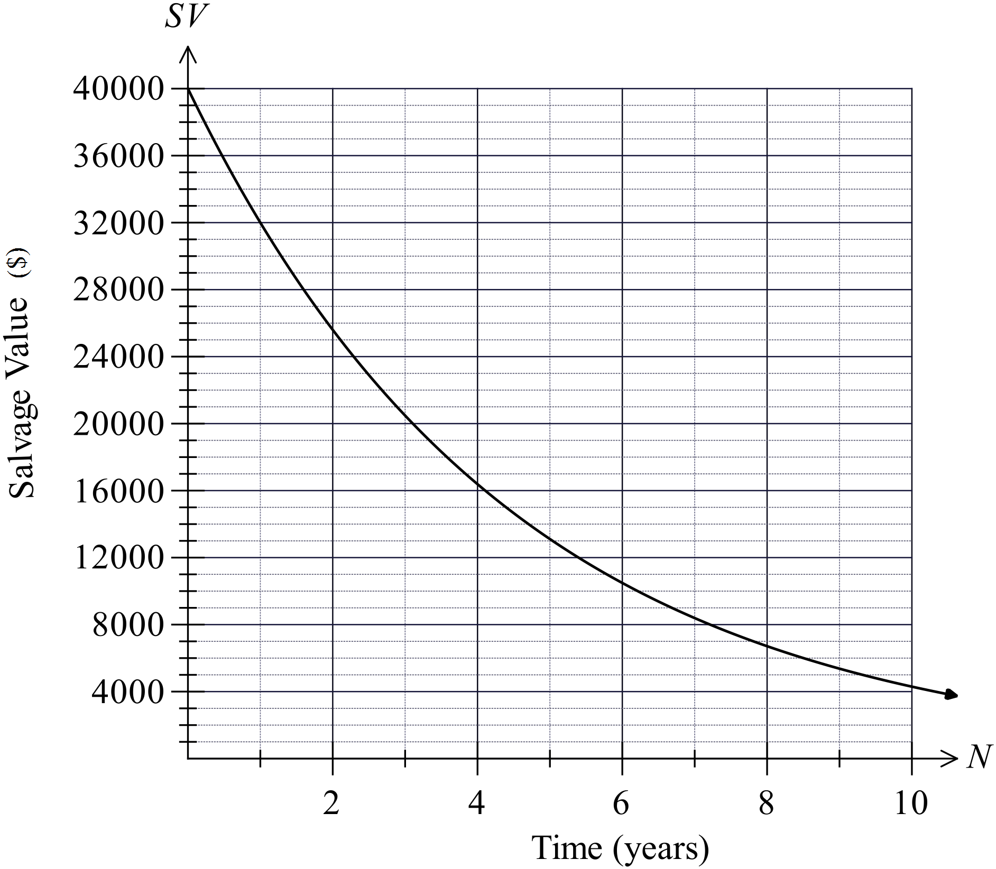How many years will Elliott keep the car?

A. 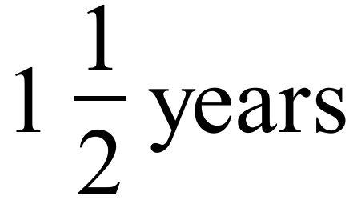
B. 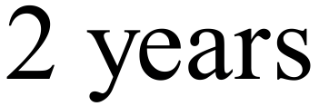
C. 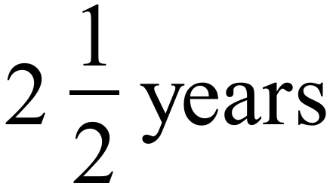
D. 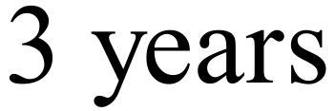

Kenzie has an annual taxable income of $45 200.
Taxable income | Tax on this income
0 – $18,200 | Nil
$18,201 – $37,000 | 19c for each $1 over $18,200
$37,001 – $80,000 | $3,572 plus 32.5c for each $1 over $37,000
$80,001 – $180,000 | $17,547 plus 37c for each $1 over $80,000
$180,001 and over | $54,547 plus 45c for each $1 over $180,000
How much income tax should she pay for the year, based on the table above?
A. $2 665 B. $3 572 C. $4 125 D. $6 237
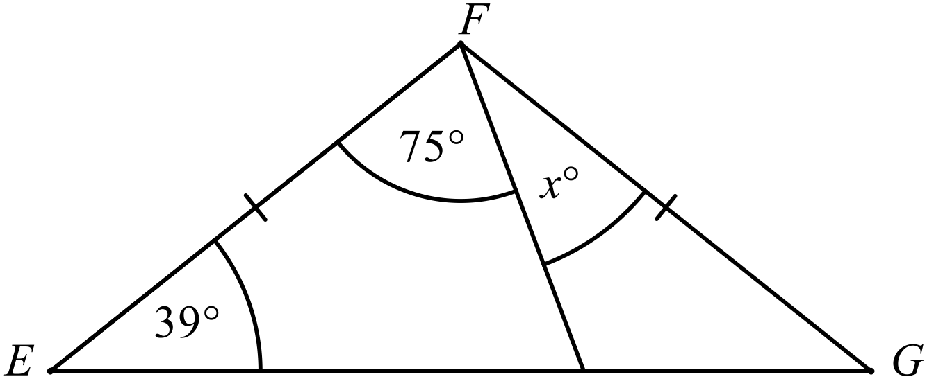
Find the value of x.

A. 27º B. 39º C. 78º D. 102º
In the diagram below, ABCD is a parallelogram and CEFD is a rhombus.
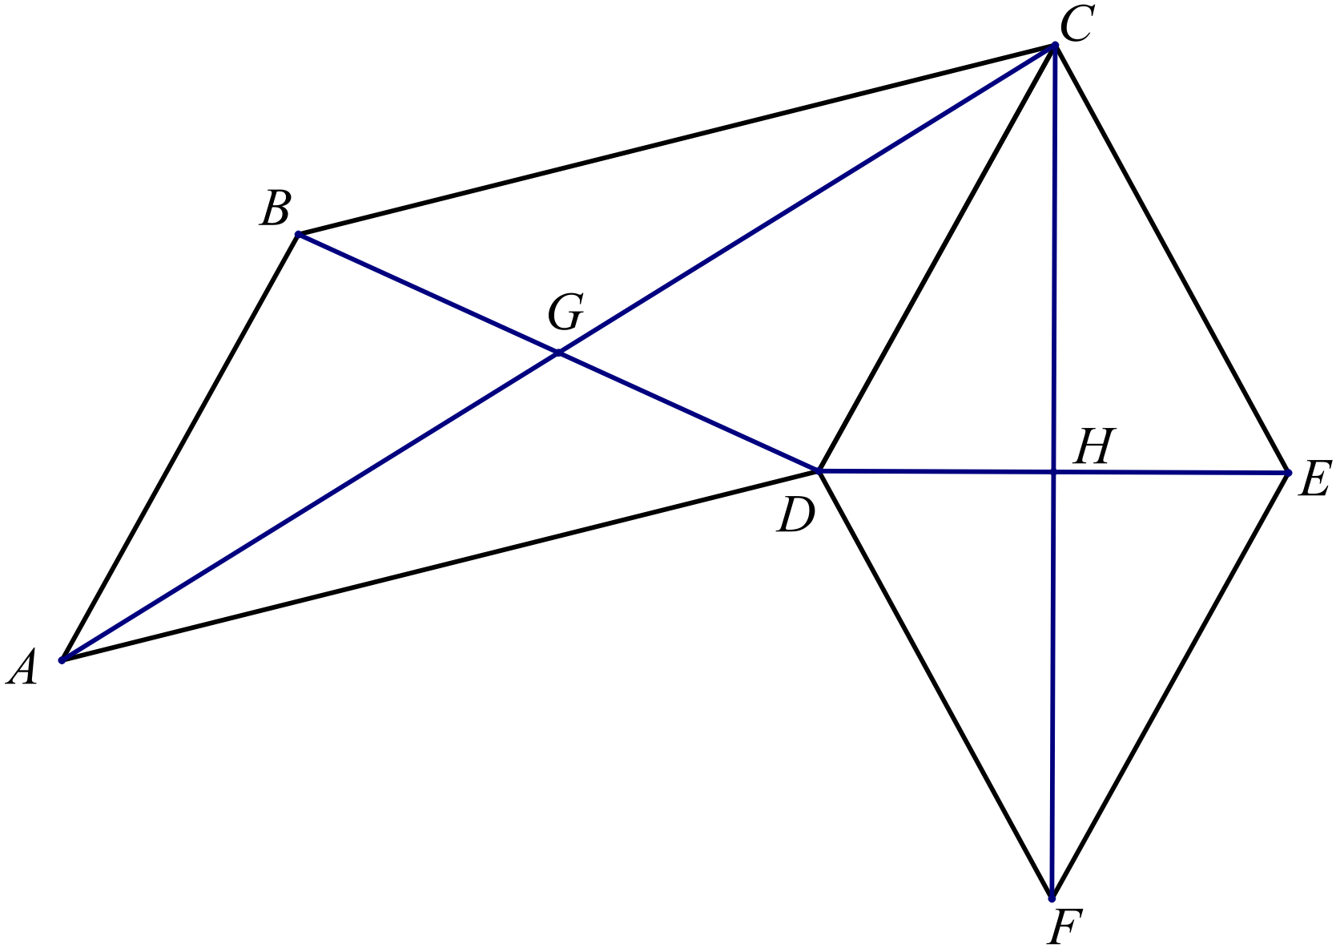Which of the following pairs of lines are perpendicular?

A. AC and BD
B. BD and CD
C. CD and DE
D. DE and CF

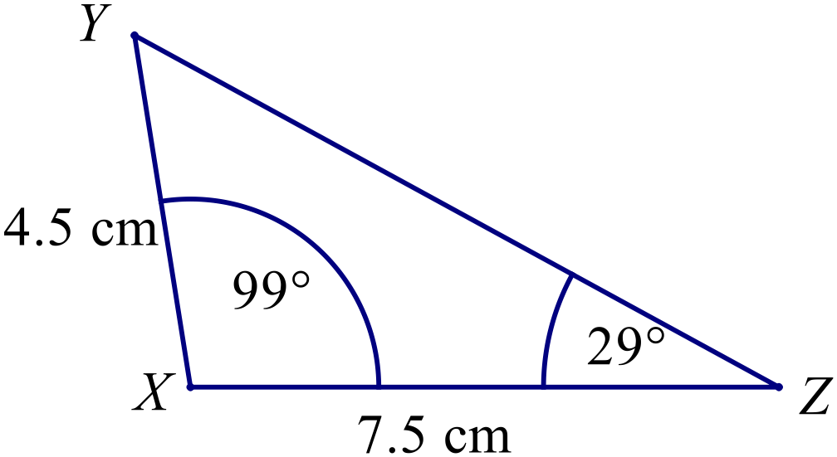Which triangle below is congruent to 

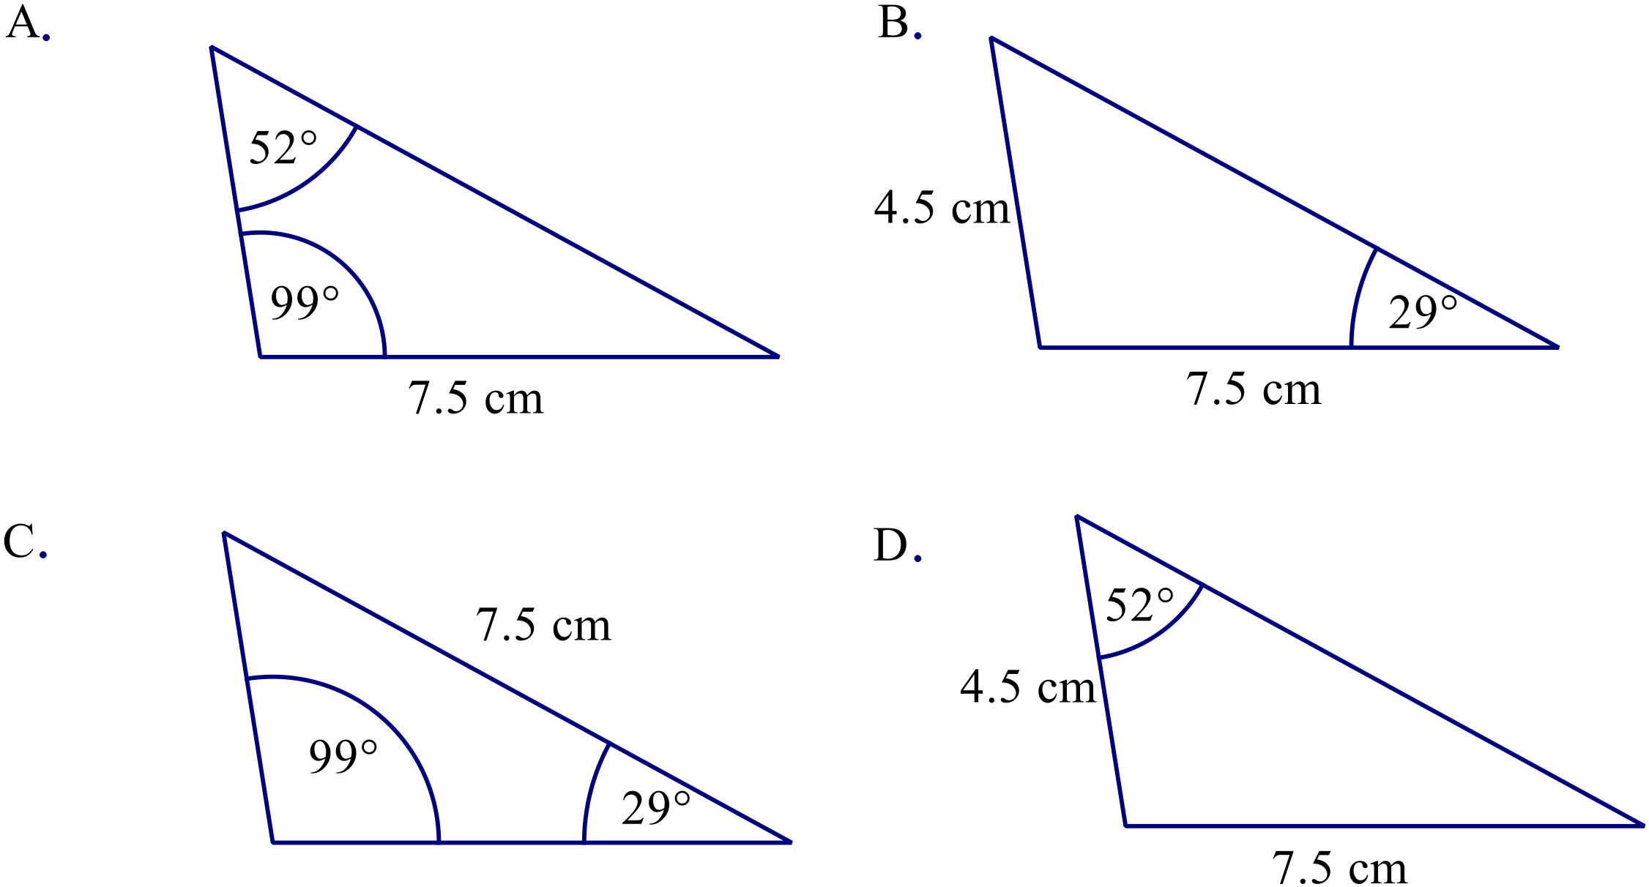

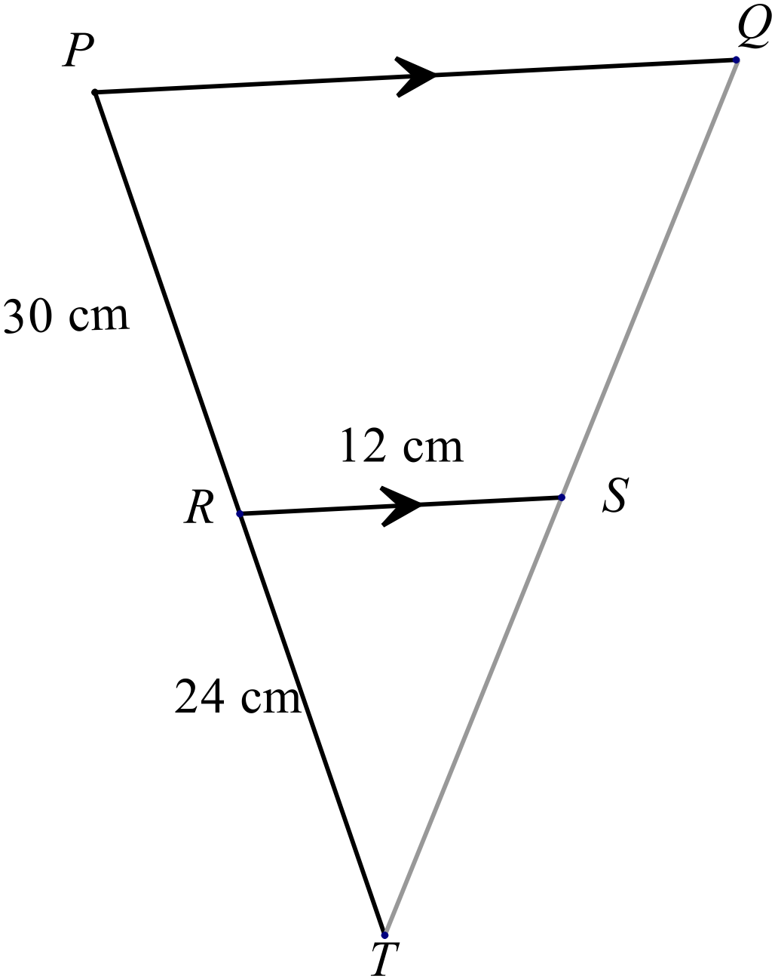In the diagram PQ || RS, PR = 30 cm, RT = 24 cm and RS = 12 cm.

What is the length of PQ?

A. 15 cm
B. 21 cm
C. 27 cm
D. 36 cm
What is the area of this shape (correct to 1 decimal place)?
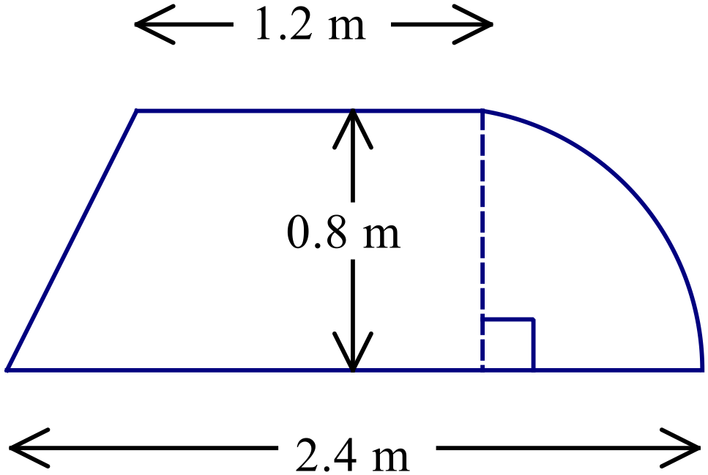

A. 0.5 m² B. 1.1 m² C. 1.6 m² D. 2.1 m²
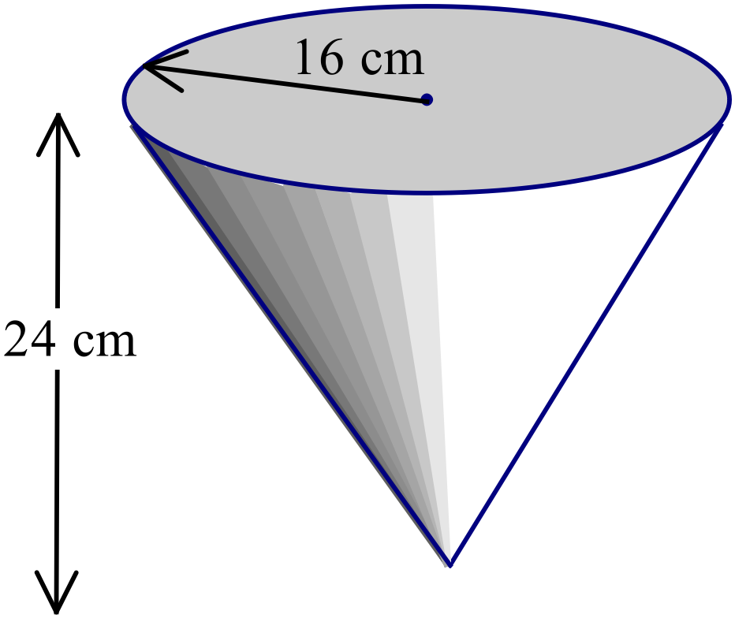What is the volume of the cone shown?

A. 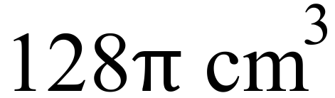
B. 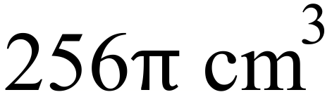
C. 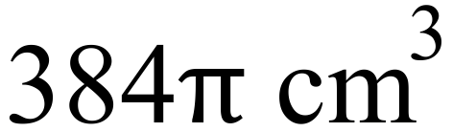
D. 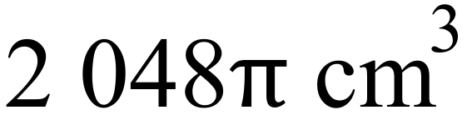
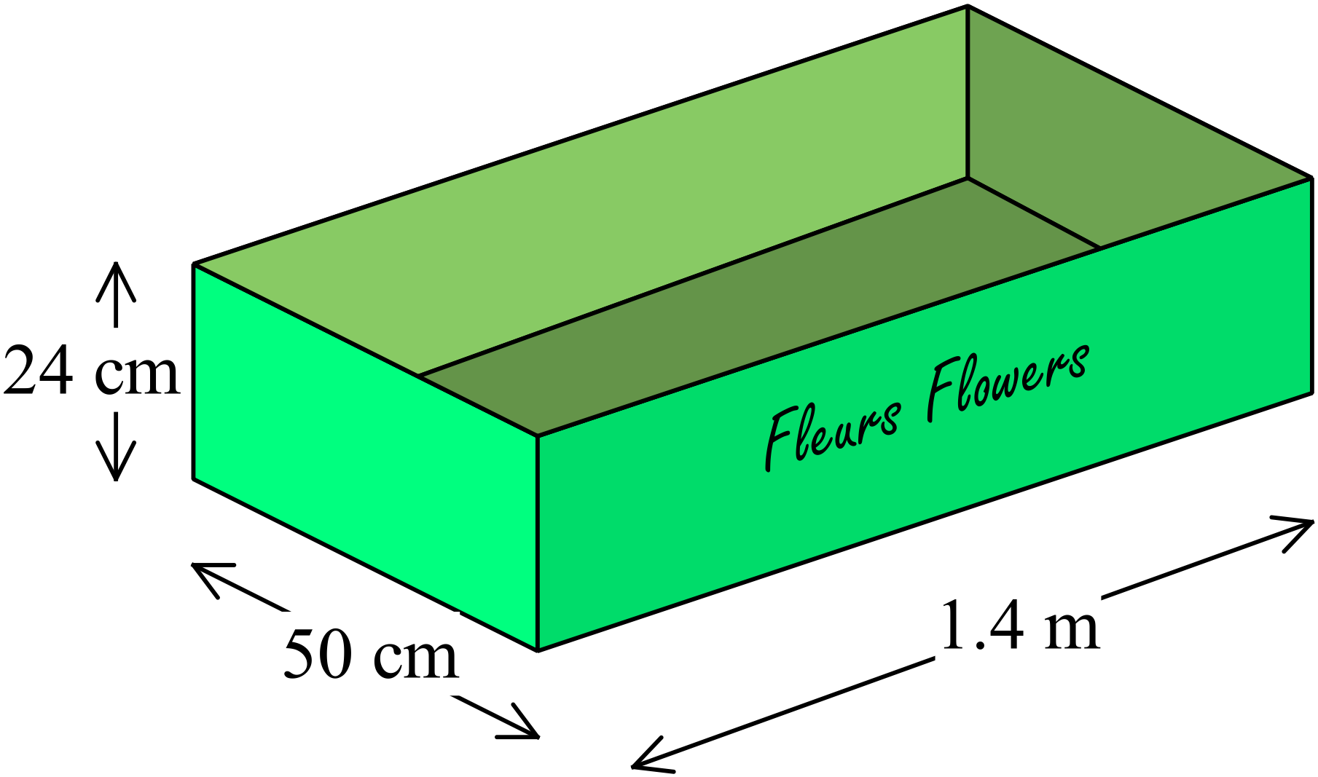Open rectangular cardboard boxes with the dimensions shown are used to pack flowers for sending to a florist.
What area of cardboard is needed for one of these boxes?

A. 2 537.2 cm² B. 2 607.2 cm²
C. 16 120 cm² D. 16 310 cm²
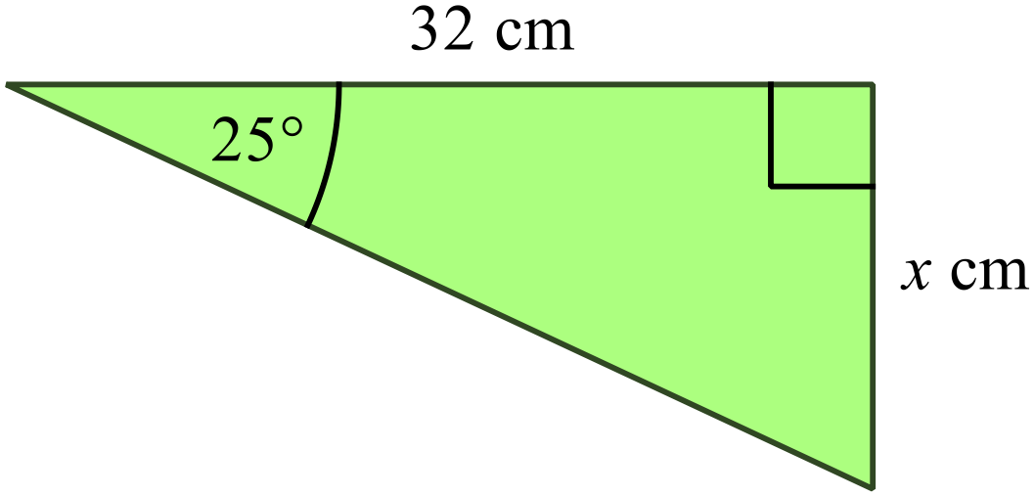What is the value of x in the diagram?

A. 13.5 B. 14.9

C. 15.6 D. 29.0

What is the angle of elevation of the top of the tower (T) from point A?
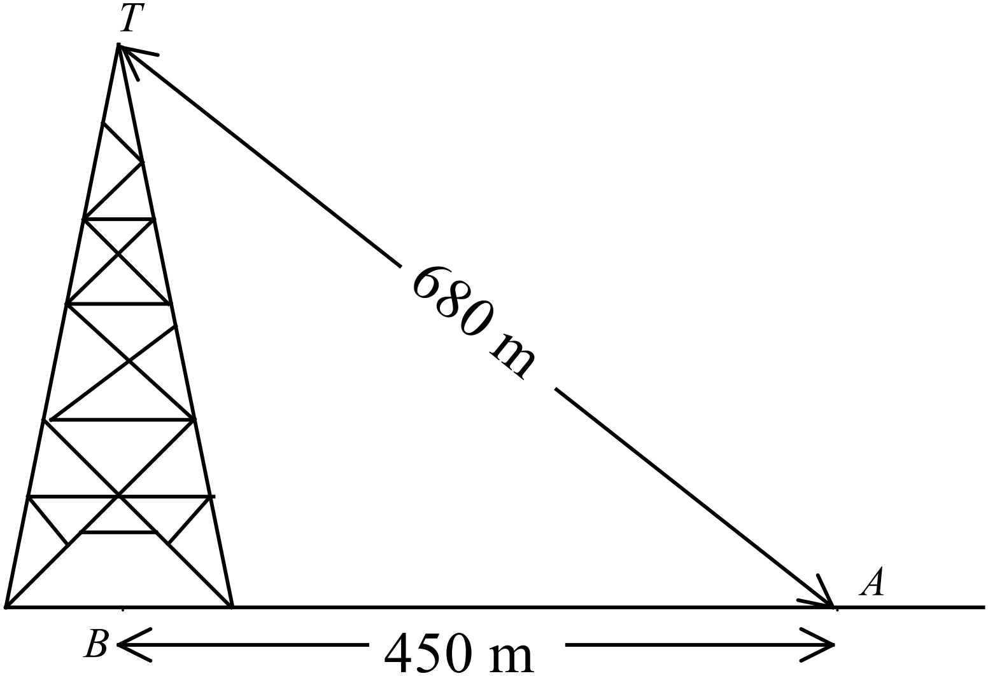

A. 33º
B. 41º
C. 49º
D. 66º
Expand and simplify 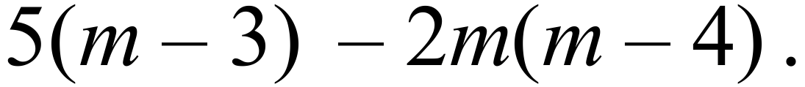
A. 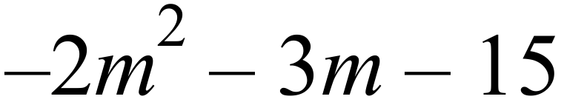
B. 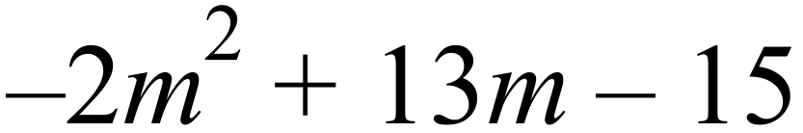
C. 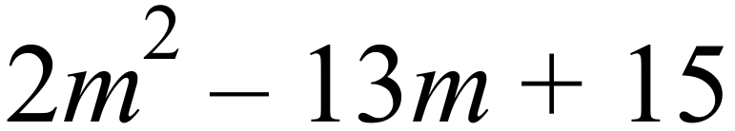
D. 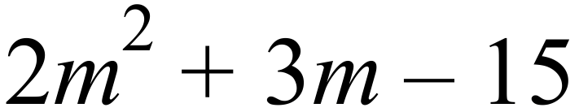
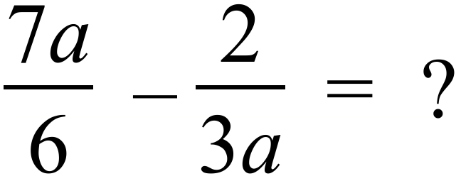
A. 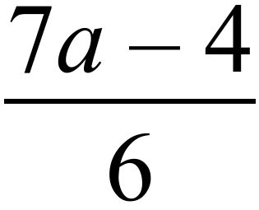 B. 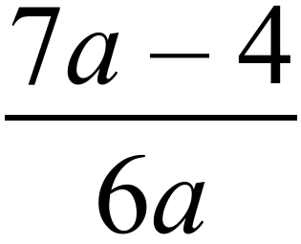 C. 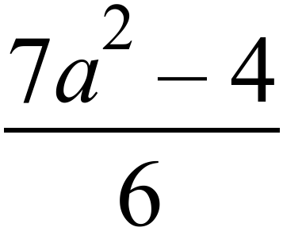 D. 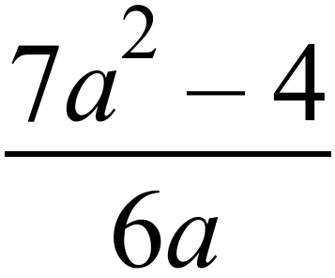
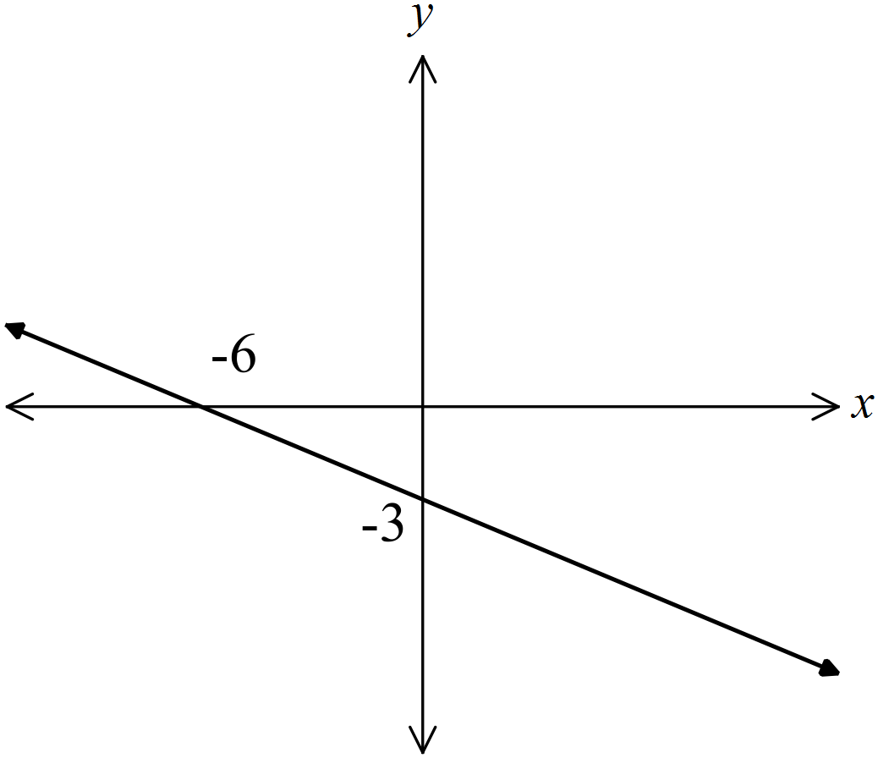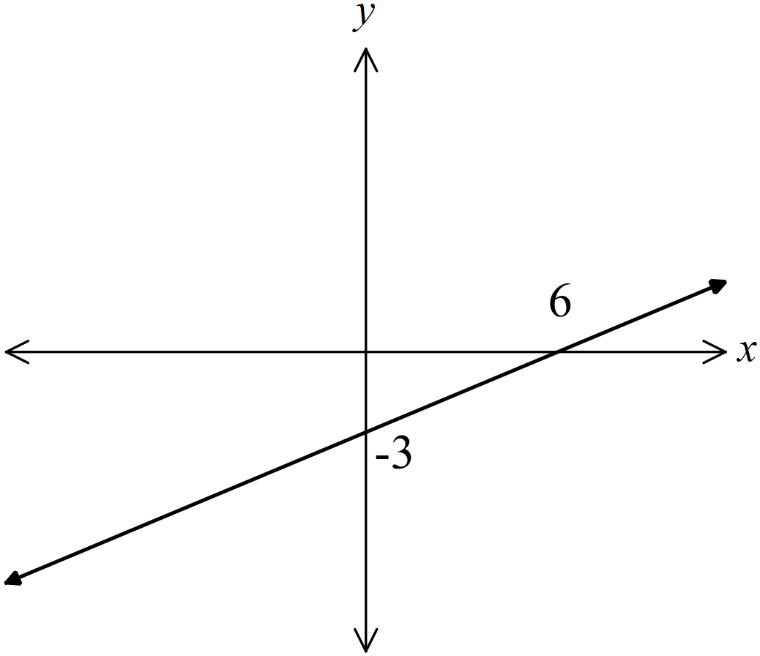Which line has an equation of 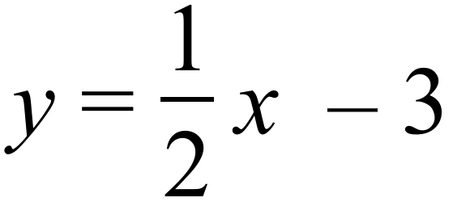 ?
A. B.

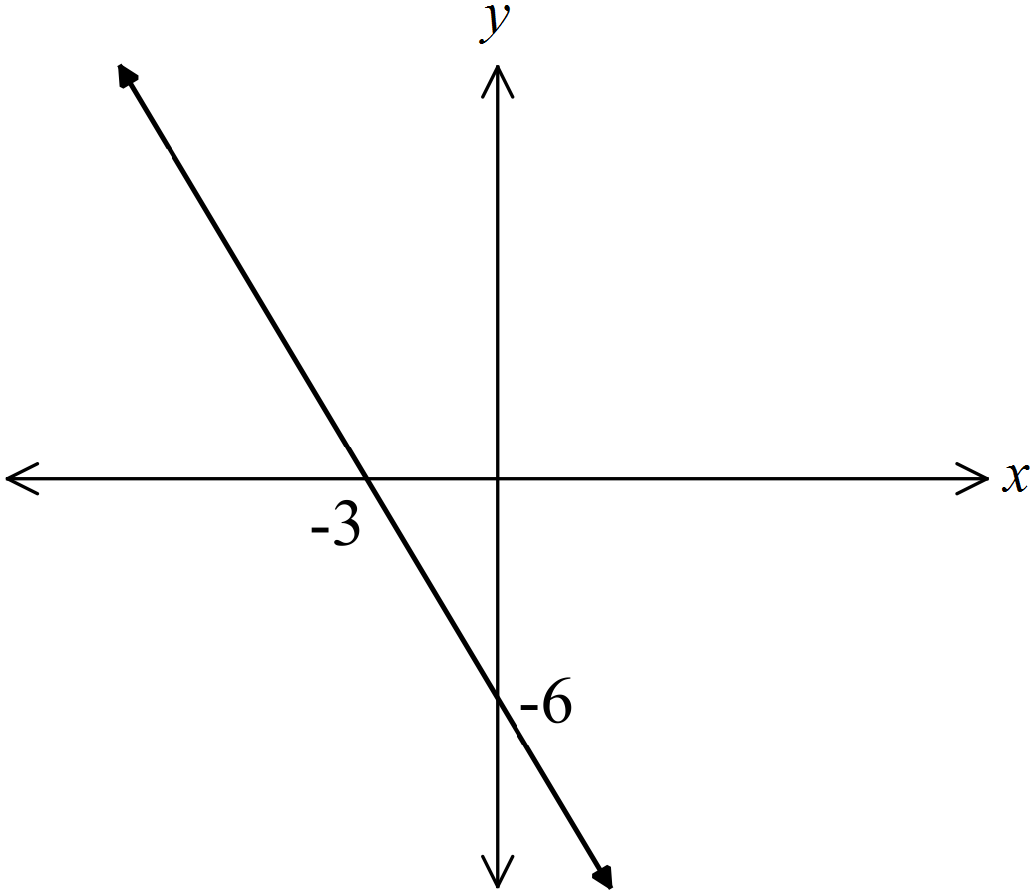
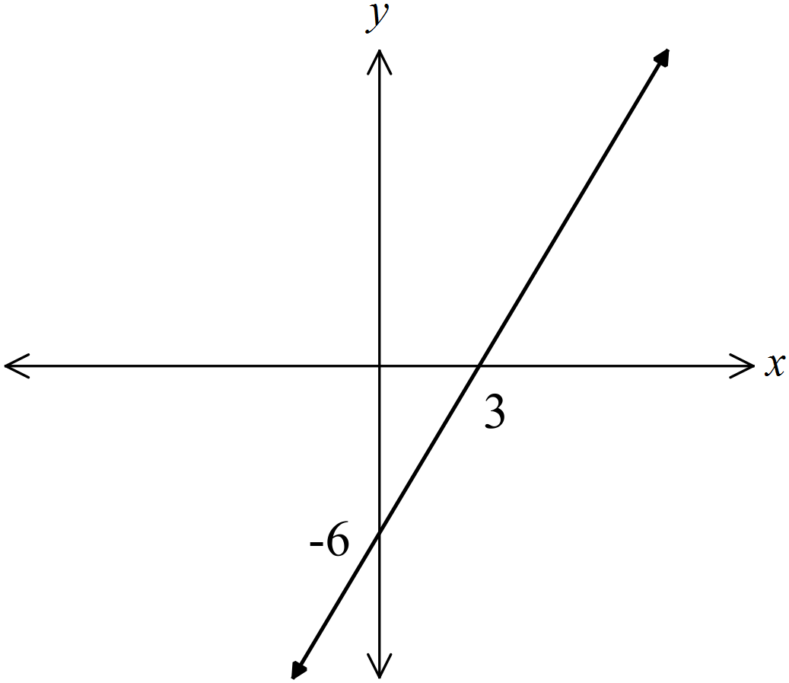 C. D.

The distance-time graph shows Noah’s trip to his grandparent’s home and back.
He started from home at noon and arrived back home at 8 pm.
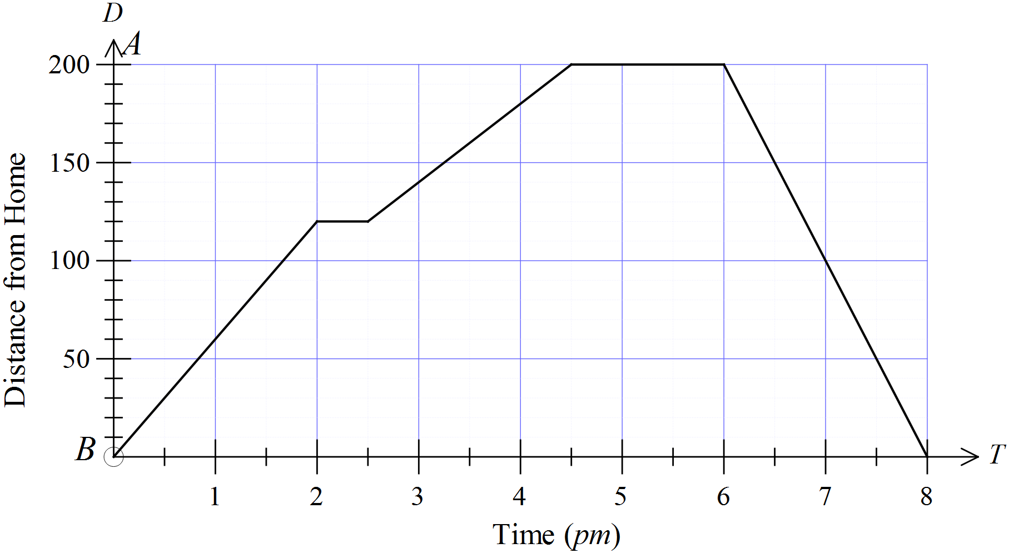

Which is not true?
A. Noah travelled at an average speed of 80 km/h on his return journey.
B. Noah stopped once on the way to his grandparent’s house.
C. Noah stayed at his grandparent’s house for an hour and a half.
D. Noah’s slowest average speed (apart from being stopped) was between 2:30 pm and 4:30 pm.
Which expression is not equivalent to 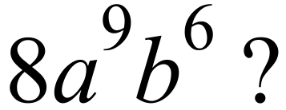

A. 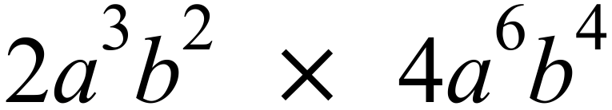 B. 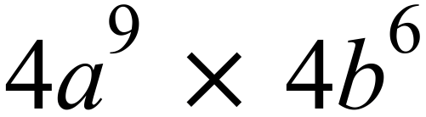
C. 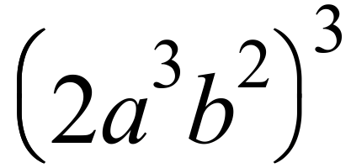 D. 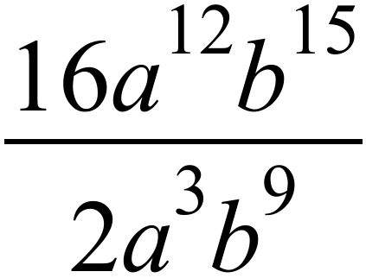
Which inequality has its solution graphed below?
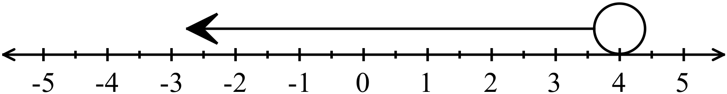

A. 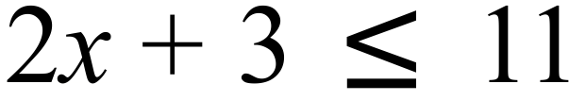 B. 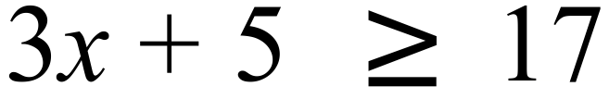
C. 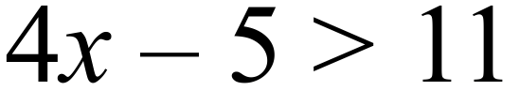 D. 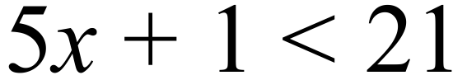
Hunter, Iain and Jason run against one another in a three man race.
Hunter has a 1 in 7 chance of winning and Iain is twice as likely to win as Jason.
What is the probability that Jason wins?
A. 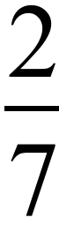 B. 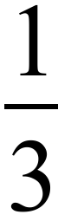 C.  D. 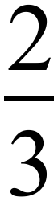
Which of these will always have a probability of 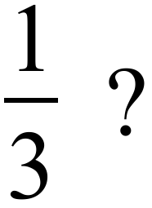
A. Rolling a 2 or a 5 on a single roll of a fair die.
B. Drawing a club from a normal pack of cards.
C. Reaching a set of traffic lights when they are showing red.
D. Drawing a red marble from a bag which holds one red and three yellow marbles.
A real estate website gives the median house price for each suburb. The median was used because:
A. The median is calculated using all the prices and the mean is not.
B. The median gives a better idea of the spread of the data.
C. The median is less effected by outliers than the mode.
D. The median is less effected by outliers than the mean.
The graph is a grouped frequency histogram which shows the ages of people at Jamie’s party.

Use the graph to estimate the mean of the data.
A. 17.0 B. 17.4 C. 18.0 D. 18.4
Which scatter graph indicates there is a positive linear relationship between the two variables?
A. B.

C. D.

End of Section 2 – Part A

Section 2  Part B  Longer Answer Section |  | Name : _______________________________
 |  | Class/Teacher___________________________
Write all working and answers in the spaces provided on this examination paper.
Calculators are allowed for this section.

 |  | Marks
76. | Wesley is a car salesperson who is paid a weekly retainer of $325 and a commission of 1.5% of the value of his sales.
 | - In a week Wesley sold three cars valued at $12 500, $24 000 and $45 000.  What is Wesley’s gross pay for that week?  ………………………………………………………………………………………………  ………………………………………………………………………………………………. | 2
 | - Wesley’s employer deducts 28% in pay-as-you-go tax instalments from his gross pay and also deducts $27.80 weekly in health fund payments. What is Wesley’s net weekly pay?  ………………………………………………………………………………………………  ………………………………………………………………………………………………. | 1
77. | The points A (-7, 3) , B (3, 3), C (6, -4) and D (-4, -4) are plotted on the number plane below and joined to form a quadrilateral.  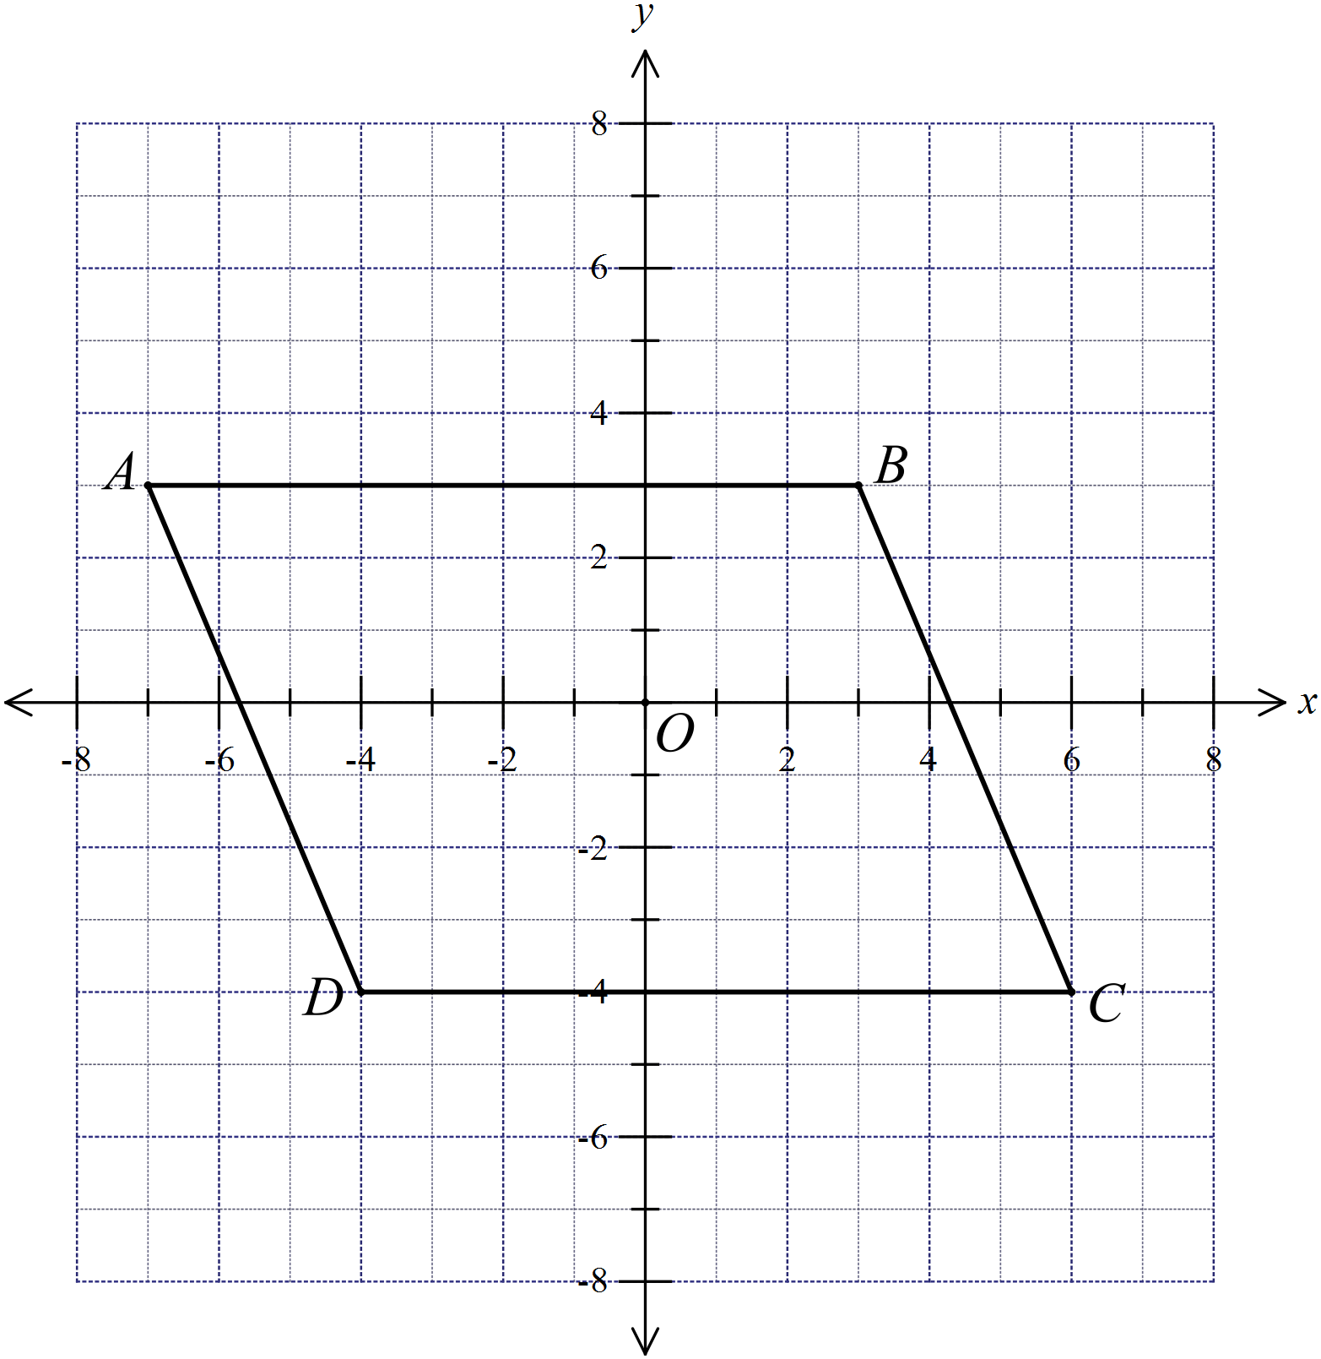
 | (a) Explain why AB is parallel to DC.  ………………………………………………………………………………………………  ………………………………………………………………………………………………. | 1
 | (b) Find the gradient of AD and show that AD is parallel to BC.  ………………………………………………………………………………………………  ………………………………………………………………………………………………. | 1
 | (c) Name the quadrilateral ABCD.  ………………………………………………………………………………………………. | 1
 | (d) Find the area of the quadrilateral ABCD.  ………………………………………………………………………………………………  ………………………………………………………………………………………………. | 1
78. | 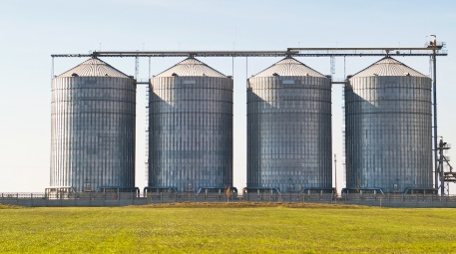  The four grain silos shown are cylindrical. Each is 25 metres high and has a diameter of 12 metres.
 | - Calculate the volume of one silo (to the nearest 10 m³).  ………………………………………………………………………………………………  ………………………………………………………………………………………………. | 1
 | (b) A conveyor belt can deliver grain to the silos at a rate of 0.5 m³/s.  How long would it take to fill the four silos, from empty (to the nearest half hour)?  ………………………………………………………………………………………………  ………………………………………………………………………………………………. | 2
79. | 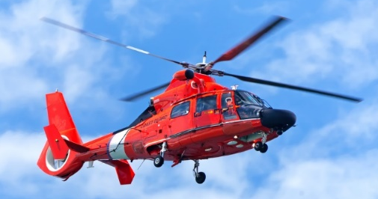  A helicopter picks up a patient from an accident A and flies 32.8 km on a bearing of 226º to land on a hospital helipad H.  An ambulance leaves the same accident and drives due south to an intersection I, and then due west to the hospital.
 | 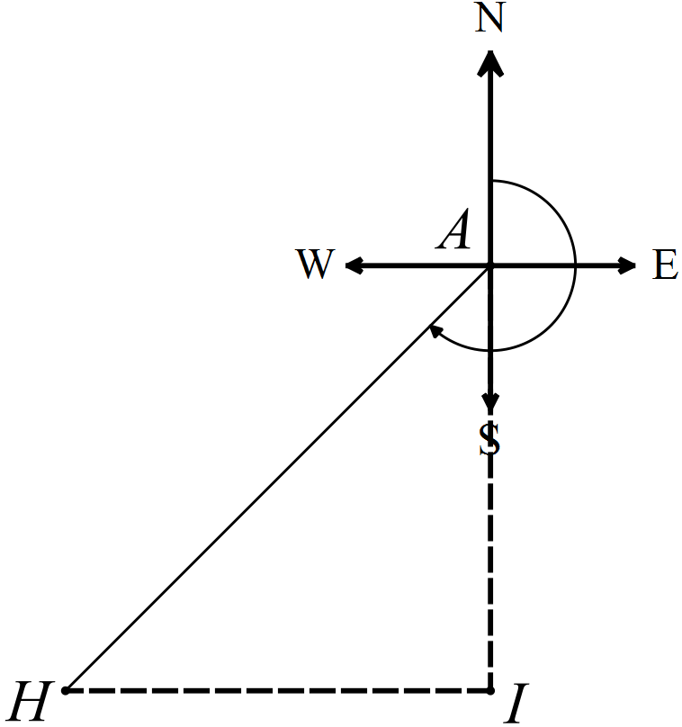 (a) Complete the diagram shown, using the information provided. | 1
 | (b) How far does the ambulance travel going from the accident A to the intersection I ?  ………………………………………………………………………………………………  ………………………………………………………………………………………………. | 1
 | (c) How much further does the ambulance travel, compared to the helicopter.  ………………………………………………………………………………………………  ………………………………………………………………………………………………. | 2
80. | Ariel rolls a pair of dice as a part of a board game.  She records the possible outcomes in the table below.  
   | 1 | 2 | 3 | 4 | 5 | 6
  1 | 1, 1 | 1, 2 | 1, 3 | 1, 4 | 1, 5 | 1, 6
  2 | 2, 1 | 2, 2 | 2, 3 | 2, 4 | 2, 5 | 2, 6
  3 | 3, 1 | 3, 2 | 3, 3 | 3, 4 | 3, 5 | 3, 6
  4 | 4, 1 | 4, 2 | 4, 3 | 4, 4 | 4, 5 | 4, 6
  5 | 5, 1 | 5, 2 | 5, 3 | 5, 4 | 5, 5 | 5, 6
  6 | 6, 1 | 6, 2 | 6, 3 | 6, 4 | 6, 5 | 6, 6
 | (a) On any one roll, what is the probability that the two dice show the same number?  ………………………………………………………………………………………………  ………………………………………………………………………………………………. | 1
 | (b) What is the probability that the numbers on the two dice have a product of 12?  ………………………………………………………………………………………………  ………………………………………………………………………………………………. | 1
81. | The dot plot shown was drawn up by Mr Jones to illustrate the results on a ten mark quiz.
   |  |  |  |  | ● |  | ●
   |  |  |  |  | ● |  | ● |  | ●
   |  |  |  | ● | ● |  | ● | ● | ●
   |  |  | ● | ● | ● |  | ● | ● | ● | ●
   |  |  | ● | ● | ● | ● | ● | ● | ● | ●
   |  |  | 3 | 4 | 5 | 6 | 7 | 8 | 9 | 10
 | (a) Mr Jones described the results as bimodal. Explain what he meant by this.  ………………………………………………………………………………………………  ………………………………………………………………………………………………. | 1
 | (b) What is the median of the data?  ……………………………………………………………………………………………… | 1
 | (c) Calculate the mean of the data.  ………………………………………………………………………………………………  ……………………………………………………………………………………………… | 1
82. | In the diagram below, is an isosceles triangle.  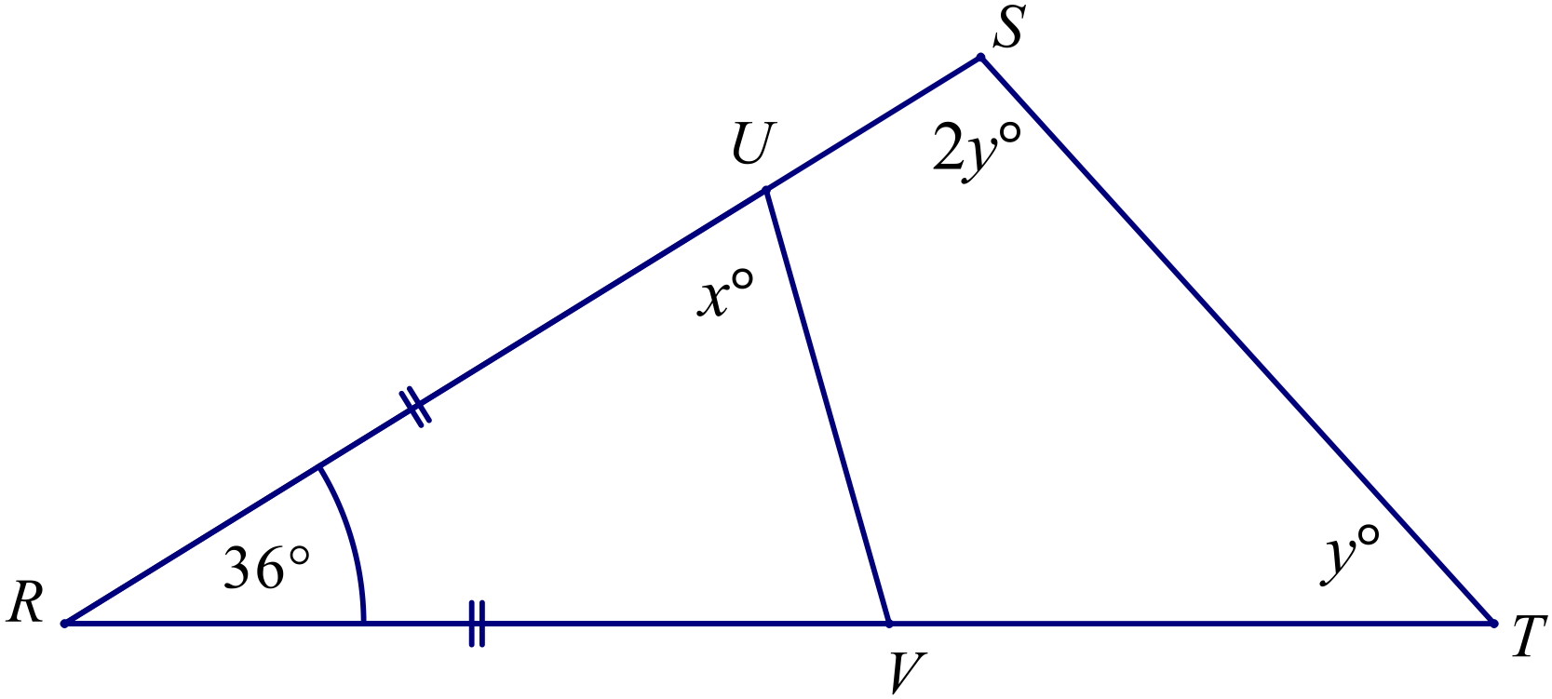
 | - Explain why x = 72.  …..……………………………………………………………………………………  ………………………………………………………………………………………. | 1
 | - Find the value of y; giving reasons.  …..……………………………………………………………………………………  …………………………………………………………………………………………  …..……………………………………………………………………………………  …………………………………………………………………………………………. | 2
83. | A tree casts a shadow which is 12.8 m long on level ground.  At the same time, a man who is 1.8 m tall, casts a shadow which is 1.5 m long.  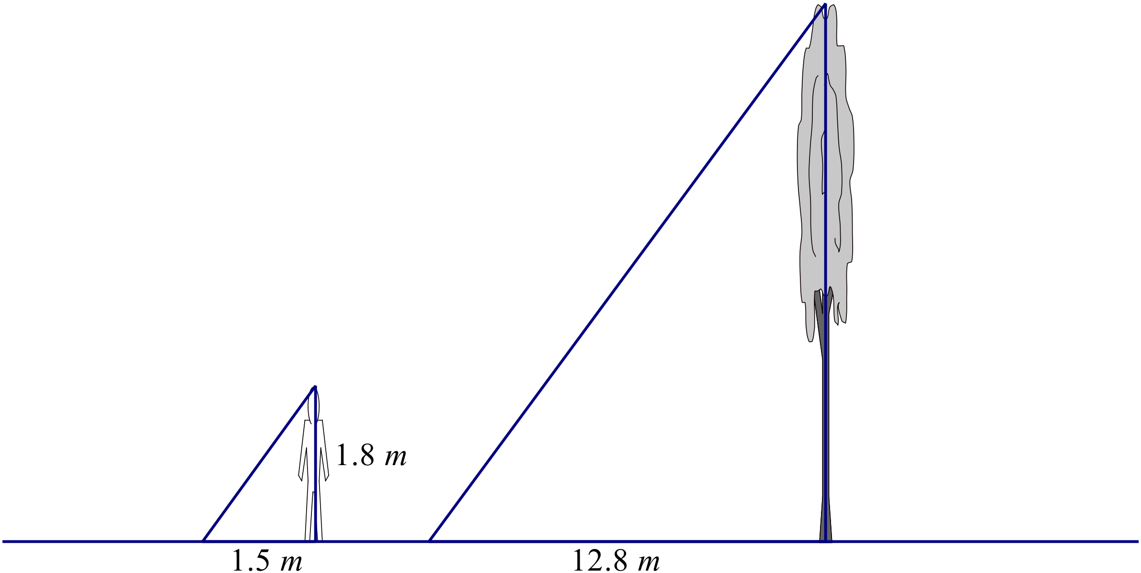  Calculate the height of the tree to the nearest tenth of a metre.  …..……………………………………………………………………………………  …………………………………………………………………………………………  …..…………………………………………………………………………………… | 2
 | End of Exam

High School
2014 Yearly Exam
Mathematics Course
Multiple Choice Section Answer Sheet
Name ________________________________ Teacher ________________________

Completely fill the response oval representing the most correct answer.

26. A B C D
27. A B C D
28. A B C D
29. A B C D
30. A B C D
31. A B C D
32. A B C D
33. A B C D
34. A B C D
35. A B C D
36. A B C D
37. A B C D
38. A B C D
39. A B C D
40. A B C D
41. A B C D
42. A B C D
43. A B C D
44. A B C D
45. A B C D
46. A B C D
47. A B C D
48. A B C D
49. A B C D
50. A B C D

51. A B C D
52. A B C D
53. A B C D
54. A B C D
55. A B C D
56. A B C D
57. A B C D
58. A B C D
59. A B C D
60. A B C D
61. A B C D
62. A B C D
63. A B C D
64. A B C D
65. A B C D
66. A B C D
67. A B C D
68. A B C D
69. A B C D
70. A B C D
71. A B C D
72. A B C D
73. A B C D
74. A B C D
75. A B C D

